

**MODERN FARMER**

BY

**LUKE TEMBANI MUNYANDU**

Submitted in partial fulfilment of the requirements for the degree

BACHELOR TECHNOLOGY: CAPSTONE DESIGN

In the

Department of SOFTWARE ENGINEERING

SCHOOL OF INFORMATION SCIENCES AND TECHNOLOGY

HARARE INSTITUTE OF TECHNOLOGY

Supervisor: **SIMBAI ZINDOWE**

# Abstract

Zimbabwe's poultry farming sector faces challenges due to limited information access, unreliable supply chains, disease management, and market opacity, hindering local farmers' growth. To combat these issues, we propose Modern Farmer, a mobile app leveraging technology to revolutionize poultry farming. It offers real-time environmental monitoring for chicken coops through IoT, automated air regulation, and infrared lighting. Interactive features predict feed quantity and weight per chick, alongside a poultry marketplace connecting farmers with customers. Modern Farmer prioritizes offline access and secure transactions, aiming to empower farmers, optimize operations, and boost economic outcomes in Zimbabwe's poultry industry.

# Preface

Poultry farming in Zimbabwe faces numerous obstacles, including limited access to information, unreliable supply chains, inadequate disease management, and market opacity. These challenges significantly impede the growth and success of local farmers. In response to these pressing issues, we have developed Modern Farmer, an innovative mobile application designed to transform the poultry farming landscape through the use of advanced technology.

Modern Farmer offers real-time environmental monitoring for chicken coops via Internet of Things (IoT) technology, automated air regulation, and infrared lighting. The app's interactive features predict feed quantity and weight per chick, ensuring precise and efficient management. Additionally, a built-in poultry marketplace connects farmers directly with customers, facilitating better market access.

A key focus of Modern Farmer is its ability to function offline, ensuring that farmers in remote areas can still benefit from its features. Secure transaction capabilities further enhance the app's utility, providing a reliable platform for trade and economic growth.

This project aims to empower poultry farmers in Zimbabwe by optimizing their operations and improving economic outcomes. We believe that by harnessing the power of technology, we can address the current challenges and foster a more prosperous future for the poultry farming industry in Zimbabwe.

# Acknowledgements

I would like to take this opportunity to express my heartfelt gratitude to everyone who has contributed to the successful completion of this project.

First and foremost, I wish to thank God for His grace, which has supported me from my first day of pre-school to this significant milestone.

I am deeply grateful to my supervisor, Ms. Simbai Zindowe, for her invaluable guidance, expert advice, and unwavering support throughout the project. Her mentorship has been crucial in shaping the direction of this work and helping me develop essential skills and knowledge in this field.

I also wish to extend my thanks to the staff of the Software Engineering Department for their assistance and support, particularly during the challenging phases of this project. The department's resources and facilities have been instrumental in conducting the research and development activities.

My sincere appreciation goes to the Development Team at FIGJAM for their exceptional collaboration and technical expertise. Their dedication and hard work have been pivotal in overcoming obstacles and ensuring the project's success.

Lastly, I would like to thank all the participants who volunteered their time and efforts to provide valuable data for this project. Their cooperation and contributions have been essential to the successful completion of this work.

Once again, I extend my heartfelt thanks to everyone who has played a role in this project. Your support and contributions have been invaluable, and I am profoundly grateful for your presence in my life.

# Declaration

I, Luke Tembani Munyandu, hereby declare that this project report has not been previously accepted for any degree and is not currently being submitted for any degree.

Student’s signature: ………………………… Date………………………….

(Luke Tembani Munyandu)

Supervisor’s signature: …………………… Date………………………….

(Ms Simbai Zindowe).

Table of Contents

Abstract 2

Preface 3

Acknowledgements 4

Declaration 5

Chapter 1: Introduction 9

Introduction 9

Background 9

Problem Statement 9

Objectives 9

Hypothesis 10

Justification 11

Proposed Tools 12

Feasibility Study 12

Technical 12

Economic 13

Operational 13

Project Plan Time Plan 14

Chapter 2: Literature Review 15

Autonomous coop cooling system using renewable energy and water recycling 15

IOT Based Smart Poultry Farm 15

Temperature and Humidity Monitoring System in Broiler Poultry Farm 16

Remote Monitoring and Control of Poultry Farm using IoT Techniques 16

Fivet Temperature Logger 17

Chapter 3: Analysis 19

Information Gathering Tools 19

Description of System 21

Data Flow Diagram (DFD) Of Existing System 22

Flow chart of current system 23

Use Case for Current System 24

Evaluation of Alternative Systems 24

Visits by vets 24

Functional Analysis of proposed system 25

Functional Requirements 25

Non Functional Requirements 26

Use Case Diagrams for Proposed System 26

Chapter 4: Design 27

Solution Architecture 27

Activity Diagram 28

ER Diagram 29

Normalized Databases 30

Users Table 30

Company Table 30

Chicken Feed Orders Table 31

Chicks Placement Table 31

Chicks for Sale Table 32

Weather Data Table 33

Veterinarians Table 33

Company Stock Table 33

Components Table 34

Market Place Order 34

Feed Order Lines 35

Class Diagram 36

Sequence Diagram 37

Interface Design 38

Web Portal for Suppliers 38

Mobile App for Farmers 45

Chapter 5: Implementation & Testing 49

Code of Major Modules 49

Raspberry PI Code 49

NodeJs Backend Code 51

React Frontend Code 56

Mobile Application Code (Java, Android) 59

Software Testing 61

Unit 61

Module 62

Integration 63

System 64

Database 65

Acceptance 65

Chapter 6: Conclusions and Recommendations 67

Summary 67

Limitations 68

Recommendations 69

Future Works 70

Conclusion 71

References 72

Bibliography 75

Interview Responses 75

Questionnaire Response 77

User Manual 79

# Chapter 1: Introduction

## Introduction

Modern Farmer is a cutting-edge mobile app revolutionizing poultry farming in Zimbabwe. It modernizes every aspect from chick procurement to sales, offering invaluable insights with real-time environmental data tailored to your chicken coop. This empowers informed decisions and operational optimization. Say goodbye to disease, inventory, and market hurdles as the app connects you with suppliers, and resources, making it accessible in remote areas. Welcome to the future of poultry farming with "Modern Farmer."

## Background

Poultry farming in Zimbabwe, a cornerstone of rural livelihoods, confronts multifaceted hurdles that necessitate innovative solutions. These challenges include limited access to crucial information, unreliable chick supply chains, disease management difficulties, and opaque market dynamics. These issues collectively impede the growth of the poultry industry and hinder the economic prosperity of local farmers.

## Problem Statement

Modern Farmer emerges as a timely and comprehensive response to these pressing concerns. By harnessing the power of mobile technology, it aims to provide practical solutions and empower poultry farmers. The project's key decisions encompass user interface design, forging partnerships with local suppliers, ensuring precise environmental data monitoring within chicken coops, and crafting effective outreach strategies. Technical challenges include enabling offline access for users with sporadic internet connectivity and establishing a secure and efficient marketplace for transactions. In sum, Modern Farmer represents an opportunity to significantly impact Zimbabwe's agricultural landscape by addressing practical issues with a meaningful, results-driven project.

## Objectives

* To implement automated air regulation, adjusting based on humidity levels and air quality parameters for optimal environmental control
* To develop an automated infrared lighting system that adjusts based on temperature level.
* To develop an interactive system to provide real-time information on both the required feed quantity for each input batch and the expected weight per chick.
* To create a poultry marketplace, connecting farmers with a broad customer base for efficient and diverse product sales.

Hypothesis  
The successful implementation of the Modern Farmer initiative, which comprises the integration of precise environmental data monitoring systems within chicken coops, the automation of lighting control based on temperature, real-time feed and weight estimations, and the introduction of a predictive disease model, is poised to trigger a transformative wave in poultry farming practices across Zimbabwe. These multifaceted improvements are projected to have a profound and positive influence on various facets of poultry farming.

First and foremost, the precise environmental data monitoring within chicken coops is envisioned to create an environment that is finely tuned to the specific needs of poultry. With optimal temperature, humidity, and ventilation, poultry health and productivity are expected to experience substantial enhancements. The implementation of automated temperature-based lighting control is set to serve a dual purpose. Not only will it contribute to the overall well-being of the birds by mimicking natural light patterns, but it will also optimize energy usage, thereby increasing the cost-effectiveness of poultry farming operations.

Furthermore, the real-time feed and weight estimations component of the project is anticipated to empower farmers with invaluable, up-to-the-minute data. This real-time information will enable farmers to make informed decisions about resource management, ensuring that feed is supplied in the right quantities and that poultry weight targets are met efficiently. The disease prediction model is another pivotal element that holds the potential to revolutionize disease management in the poultry industry. By providing early detection and predictive capabilities based on symptoms, it offers an opportunity for proactive intervention, reducing disease-related losses and preserving poultry health.

In the broader perspective, the successful execution of the Modern Farmer project is foreseen to not only revolutionize poultry farming but also stimulate substantial growth within the poultry industry. The enhancement of market access opportunities, an essential part of the project's mandate, aims to bridge existing gaps in the market and establish a secure, efficient marketplace for poultry transactions. This, in turn, is expected to fuel economic growth among local poultry farmers and thereby enhance their overall economic well-being.

## Justification

The Modern Farmer project emerges as an imperative response to these pressing concerns. By harnessing the power of mobile technology and integrating innovative solutions, this project strives to enhance poultry farming practices, empower farmers, and catalyse economic growth in the sector. Its key components encompass precise environmental data monitoring systems within chicken coops, automated temperature-based lighting control, real-time feed and weight estimations, a disease prediction model, and strategies to expand market access.

Addressing Critical Challenges: The challenges faced by poultry farmers in Zimbabwe are not merely inconveniences alone but they also threaten the very sustainability of this vital sector. The lack of access to critical information, unreliable supply chains, and disease management issues directly affect the health and productivity of poultry, limiting the potential income for farmers.

Empowering Rural Livelihoods: Poultry farming is a significant source of income for rural communities in Zimbabwe. The Modern Farmer project has the potential to uplift these communities by enhancing poultry farming practices, ultimately improving the livelihoods of local farmers and their families.

Advancing Agricultural Technology: This project represents a progressive approach to solving age-old problems in agriculture. By incorporating cutting-edge technology such as real-time data monitoring and predictive disease modelling, it is in line with global trends that promote sustainable and efficient agricultural practices.

Promoting Economic Growth: A thriving poultry industry can have far-reaching economic benefits. The expansion of market access through this project not only enhances local economic prosperity but also contributes to the broader economic landscape of Zimbabwe.

Strengthening Food Security: Poultry is a crucial source of animal protein and a healthy poultry industry contributes to food security in Zimbabwe. By enhancing poultry health and productivity, this project indirectly supports food security initiatives.

## Proposed Tools

* Raspberry Pi/ Arduino Uno R3/ Arduino Mega
* 5 LEDs
* Jumper Cables
* MQ135
* Exhaust Fan
* DTH11 & DTH22 Temperature & Humidity Sensor
* Small Cardboard box as Chicken Coup Representation
* NodeJs Backend – JS
* Java – Mobile App Development
* Vs Code
* Android Studio
* Postman

## Feasibility Study

### Technical

Platform Selection: The choice to develop the app exclusively for Android aligns with the dominant smartphone market in Zimbabwe. As Android is the preferred platform for the majority of smartphone users, it ensures that the app reaches the widest audience.

Data and Environmental Sensors: The app's integration with data and environmental sensors is promising. These sensors are readily accessible and have the capability to accurately record crucial parameters such as temperature and humidity. This ensures the reliability of the data collected, contributing to the app's effectiveness in providing real-time insights.

Scalability: "Modern Farmer" is designed to operate independently for each poultry project. This approach ensures scalability, as the app can be seamlessly adapted to various project sizes and configurations. Scalability is essential to accommodate the diverse needs of poultry farmers in Zimbabwe without compromising performance or data management.

### Economic

Market Potential: Most poultry farmers in Zimbabwe are continuously looking for better ways to manage their poultry projects. This indicates a high probability that they will readily adapt this solution. Since it's a pay-once setup, it would benefit them greatly. This demonstrates a strong market potential for "Modern Farmer" within the poultry farming community.

Cost-Benefit Analysis: Development costs for the app, web, and sensors are projected to be below $300, and there will be no ongoing expenses, making it an economical solution. Poultry farmers would significantly save on costs related to hiring staff to monitor environmental variables in coops. Additionally, they would save time and resources by avoiding the administration of incorrect medications for different problems. This cost-saving aspect is a strong point in favour of the app's economic feasibility.

Sustainability: In the long term, poultry farmers would find this solution highly beneficial, as it would lead to overall production reaping huge profits due to reduced mortality rates. This emphasizes the sustainability of the project and its potential to evolve over time, adapting to the changing needs of the poultry farming industry.

### Operational

User Acceptance: Interviews have been conducted with poultry farmers, showing that most of them are willing to adapt the system for their projects. This indicates strong user acceptance, with a willingness to embrace the app as part of their poultry farming operations. There is a positive response from the target user group.

Supplier and Buyer Engagement: Suppliers and Buyers have expressed their willingness to use the web portals to sell their feed and chicks to poultry farmers. This would help them make more sales if they start supplying poultry farmers via the app. The engagement of suppliers and buyers demonstrates a willingness to adopt the app as a means of conducting transactions, thereby enhancing the operational efficiency of the poultry farming supply chain.

Training and Support: The app comes with a user guide on how to use it, and besides, all farmers who are on boarded onto the system are offered free training sessions on all the system features. This focus on user training and support ensures that users receive the necessary guidance to effectively utilize the app. It highlights the commitment to a smooth and efficient user experience.

Data Security and Privacy: The app only collects usernames and passwords (encrypted) for user identification, and this data is highly secured such that no other person can have access to the app. The emphasis on data security and privacy instils confidence in users, addressing their concerns and ensuring their data remains protected.

## Project Plan Time Plan

|  |  |  |  |  |  |  |  |  |  |  |
| --- | --- | --- | --- | --- | --- | --- | --- | --- | --- | --- |
| **Task Name** | September | October | November | December | January | February | March | April | May | June |
| Proposal |  |  |  |  |  |  |  |  |  |  |
| Data Collection |  |  |  |  |  |  |  |  |  |  |
| Literature Review |  |  |  |  |  |  |  |  |  |  |
| Design |  |  |  |  |  |  |  |  |  |  |
| Analysis |  |  |  |  |  |  |  |  |  |  |
| Implementation |  |  |  |  |  |  |  |  |  |  |
| Testing |  |  |  |  |  |  |  |  |  |  |
| Reporting |  |  |  |  |  |  |  |  |  |  |
| Documentation |  |  |  |  |  |  |  |  |  |  |
| Submission |  |  |  |  |  |  |  |  |  |  |

# Chapter 2: Literature Review

This study's literature review focuses on similar studies that have been conducted on the challenges and problems that farmers face in trying to maintain optimal environmental conditions and water supply in chicken production. This chapter explains what other researchers in a similar field of study have done in order to put this research in context.

## Autonomous coop cooling system using renewable energy and water recycling

Khalid et al (2018) propose an autonomous chicken coop cooling system called REMACT, which uses renewable energy and water recycling to control the temperature inside the coop. The system leverages hardware components to regulate temperature inside chicken coops. According to this research paper, extreme temperatures significantly affect the growth and productivity of poultry so it is an important factor to keep track of. This study is a success in terms of temperature control but it has limitations in that it takes quite a while to regulate the temperature using water cooling system even though it is economical. It is also limited in controlling temperature only when they are other important factors like humidity and air quality in the chicken coop.

## IOT Based Smart Poultry Farm

In this study conducted by Mitkari et al (2019), an Internet of Things (IoT)-based intelligent poultry system is proposed. This system is designed to automate the process of feeding chickens and control environmental variables, particularly temperature, in poultry coops. It relies on a network of sensors to collect data within the chicken enclosures, comparing it to predefined thresholds. When a specific parameter exceeds or falls below these thresholds, the system responds by activating an alert, either in the form of a buzzer or a notification sent to the user. Subsequently, the user is responsible for taking corrective measures, such as using a pump to sprinkle water and lower the temperature in instances of high temperature.

While this research study demonstrates promise and practicality, it is worth noting that the system still incorporates a notable degree of manual intervention throughout its processes. This manual intervention could potentially impact the growth and productivity of the chickens. Furthermore, there exists the possibility that users may not be immediately available to respond when alerts are triggered, be it by the buzzer or notification. This delay may result in a protracted resolution of the issue at hand.

## Temperature and Humidity Monitoring System in Broiler Poultry Farm

Paputungan (2020) embarked on a research for monitoring temperature and humidity values in a chicken coop for broiler livestock production. The research clarifies the importance of monitoring temperature and humidity in broiler farming as these factors significantly impact growth and productivity. The prototype utilizes a sensor (DHT11) and an Arduino DUE microcontroller to automate monitoring of environmental conditions. The results of the study demonstrate that the sensor effectively captures temperature and humidity data in the chicken cage over time. After implementing the system, the mortality rate of chicks decreased from 5 to 4 chicks per day. The paper concludes by suggesting that future work should focus on controlling both temperature and humidity to further improve broiler chicken farming outcomes. This research paper is limited to temperature and humidity factors only and leaves out one possible aspect of also monitoring and controlling quality of air or amount of ammonia in the chicken coop.

## Remote Monitoring and Control of Poultry Farm using IoT Techniques

In a study conducted by E. Hitimana et al (2018), the research underscores the vital significance of monitoring and controlling environmental conditions, with a specific focus on their implications for agriculture and zoology, particularly in relation to chicken production. The study incorporates the integration of wireless sensors and mobile networks to establish a system designed for the automatic regulation of environmental parameters, including humidity, temperature, and ammonia gas levels. This innovative system promptly reacts to abrupt changes in climate, utilizing predefined threshold values as benchmarks. The intended solution seeks to mitigate environmental diseases in chicken populations, augment overall productivity, and curtail instances of human error. It is worth noting, however, that the system primarily addresses the prevention of diseases. In practice, there may still be occasional occurrences of diseases. A limitation of this system is that it does not offer guidance to farmers on how to manage specific diseases should they arise.

## Fivet Temperature Logger

Fivet offers an advanced temperature logging solution designed for monitoring and maintaining optimal conditions within your poultry enclosure. This device is strategically placed within your chicken coop, away from areas where ambient room temperature could skew the readings. To harness its capabilities, you will need to install dedicated software on your personal computer and connect it to the Temperature Logger. Once connected, the system provides real-time temperature data directly to the software running on your PC.

While this system proves to be invaluable for keeping tabs on temperature fluctuations within your poultry runs, it is not without its constraints. One notable limitation arises from the fact that this software operates exclusively on desktop computers, rendering it ineffective for remote monitoring when you are away from your PC. Additionally, when the Temperature Logger detects temperature levels surpassing predefined thresholds, manual intervention is necessary to rectify the situation.

Furthermore, it's important to note that this system solely focuses on temperature monitoring, omitting critical aspects such as ammonia concentration and humidity levels, which are also essential factors for maintaining a healthy and productive chicken environment.

Internet Based Smart Poultry Farm Mobile System

Goud and Sudharson (2015) devised an internet-based smart poultry farm mobile system that incorporated wireless sensors to notify registered individuals in charge of farms about various environmental parameters, including temperature, humidity, and water levels. A notable drawback of their system was its reliance on GSM to dispatch alerts to farm managers. This approach, dependent on GSM for information transfer, proves ineffective in areas with no cellular service. The system operates by sending a code word SMS to GSM modules, retrieving current parameter values, allowing users to take necessary actions. However, this method is susceptible to issues like network errors or failure to operate when the SIM card is not recharged.

Chicken Coop Automatic Remote Visual Monitoring System

In a study conducted by S. Wahjuni et al. (2022), a visual monitoring system was proposed and developed to assist farmers in monitoring their chicken coop, typically situated at a distance from their residences. The system relies on sufficient bandwidth for video transmission over the internet, a resource often limited in urban areas. The research aimed to create an automatic chicken coop remote monitoring system and determine the optimal video resolution for transmission. An 8 MP Raspberry Pi V2 records the video, transmitting results to Google Drive via the Google Drive API. Additionally, a live-streaming video from the chicken coop is accessible through a basic HTTP web page using ngrok as tunnelling software, enabling public access via any web browser. Experiments involved three video resolutions (640x480, 800x600, and 1024x768) with frame rates of 15 and 30. Each scenario had five-minute duration, repeated 12 times. While beneficial to farmers, the system has limitations, notably the inability to remotely control situations without manual intervention. Another limitation is the requirement for the responsible person to closely monitor the streamed video to promptly address any anomalies, resembling the effort of being physically present in the chicken coop.

# Chapter 3: Analysis

## Information Gathering Tools

* Interviews

Interview Questions

1. How many years of experience do you have in Poultry Farming?
2. Do you face any challenges in accessing resources and suppliers in your areas?
3. How accessible are modern technologies, like mobile apps, in your farming location?
4. How comfortable are you with using mobile apps for managing your poultry farm?
5. Would you want to manage your chicken farming remotely in real time and also visualize how different weather conditions in your coop are looking like?
6. Are there any additional features or improvements you would like to see in a poultry farming app like Modern Farmer?
7. Can you foresee any challenges Modern Farmer might help you overcome in disease control, inventory management, or sales?
8. What barriers or challenges do you foresee in terms of technology adoption?

* Observation

Aspects to Observe

1. Environmental Monitoring:

- Assess how farmers monitor and control environmental conditions in the chicken coop.

- Identify any manual processes or tools used.

- Note the efficiency of the current system.

1. Disease Control:

- Note the frequency of health checks and any observable signs of disease.

- Evaluate the effectiveness of current disease management practices.

1. Inventory Management and Sales:

- Assess how farmers currently manage inventory and track sales.

- Identify any areas where errors or challenges arise.

- Note the level of technology integration in these processes.

* Questionnaire

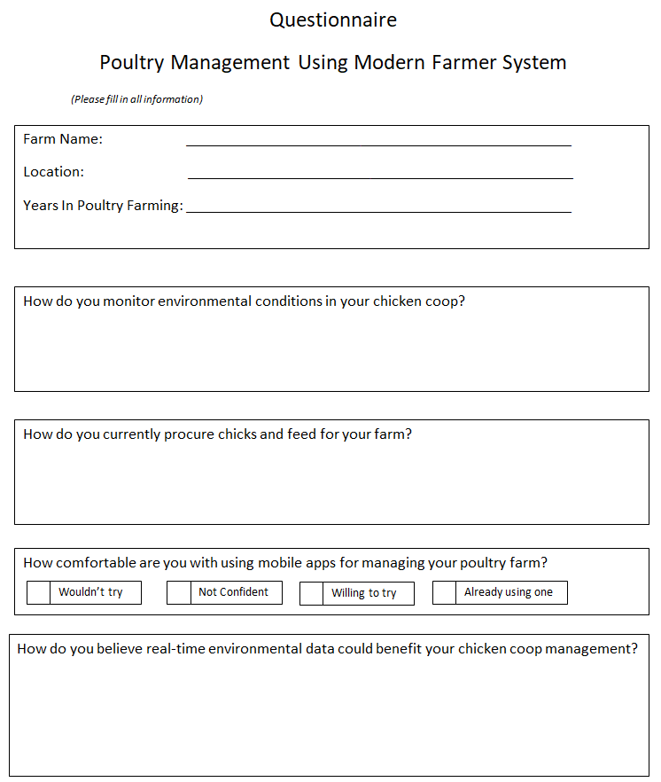

## Description of System

The existing system is characterized by a significant lack of organization, as the majority of farmers rely on intuition and often incorrect assumptions when making decisions. The current poultry management approach entails farmers employing manual labour in chicken coops and utilizing thermometers to monitor and regulate temperature levels. Maintenance of the chicken coop environment involves periodic manual checks of the thermometers, along with the adjustment of heat sources to achieve optimal conditions for maximum growth.

Moreover, the current system leaves poultry farmers without clear guidelines regarding the expected developmental milestones of their chickens within specified timeframes, such as target weights during the first 2, 4, and 6 weeks of a three-phase program. Additionally, the system necessitates that poultry farmers physically visit suppliers of feed and chick stock to place orders for supplies and medications.

Furthermore, the current system lacks a reliable source of information on poultry management, encompassing essential aspects such as project implementation and disease control. Lastly, it fails to provide poultry farmers with access to a marketplace where they can efficiently sell their produce to various buyers at equitable prices. Each farmer is compelled to navigate a challenging process when attempting to market their products.

## Data Flow Diagram (DFD) Of Existing System

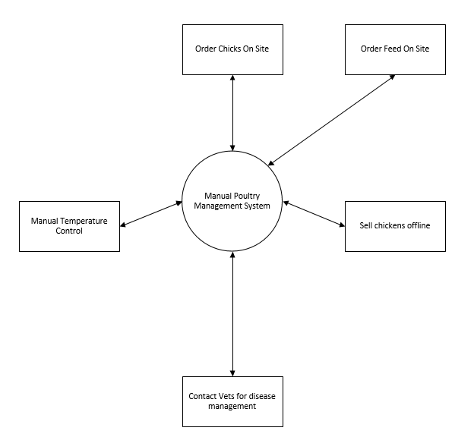

## Flow chart of current system

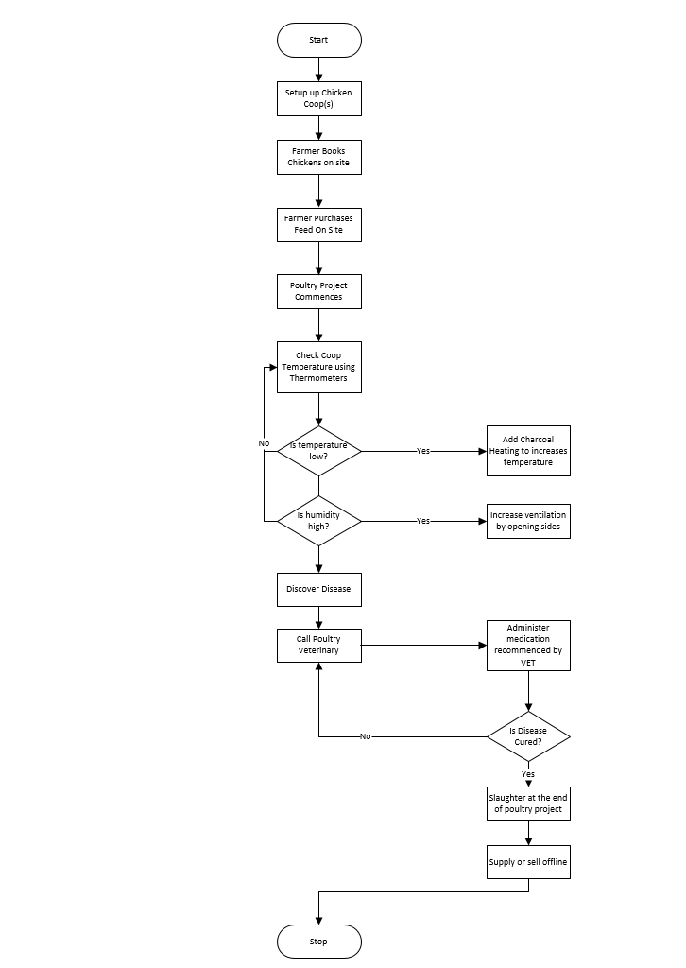

## Use Case for Current System

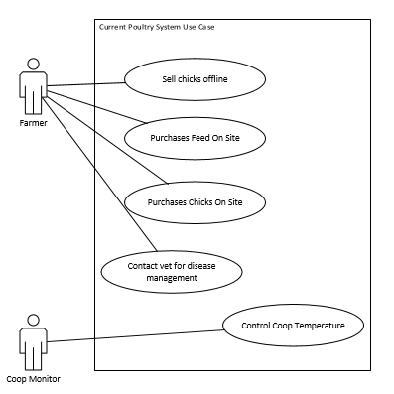

## Evaluation of Alternative Systems

### Visits by vets

Another alternative system for monitoring and maintaining the well-being of poultry farms is the traditional method of regular visits by veterinarians. While this approach has been relied upon for years, it comes with its own set of advantages and challenges. Visits by vets offer a hands-on and comprehensive assessment of the poultry farm. Veterinarians can inspect the overall health of the chickens, identify potential diseases, and provide immediate treatment if necessary. This direct observation allows for a personalized approach to addressing specific issues that may not be evident through automated systems alone.

However, relying solely on visits by vets presents certain limitations. The frequency of visits may not be sufficient for real-time monitoring, leaving gaps in identifying sudden health issues or environmental changes. Additionally, the costs associated with regular veterinary visits can be significant, making it less feasible for small-scale poultry farmers.

Moreover, the availability of experienced poultry veterinarians might be limited in remote areas, hindering accessibility to this crucial aspect of farm management. This dependency on human intervention also introduces the risk of delays in addressing emerging problems, potentially impacting the overall health and productivity of the chicken flock.

Temperature Logger by Fivet

In comparison to the Fivet Temperature Logger, the vet visit approach provides a more holistic assessment but lacks the immediacy and continuous monitoring capabilities that an automated system offers. The choice between these alternatives depends on the specific needs, scale, and resources of the poultry farm. As we delve deeper into the evaluation of alternative systems, it becomes evident that a comprehensive and technologically advanced solution is essential to overcome the limitations posed by individual methods. The "Modern Farmer" app, with its integration of various functionalities, aims to address these shortcomings and provide a unified platform for efficient poultry farm management.

# Functional Analysis of proposed system

## Functional Requirements

* System should allow farmers to monitor coop temperature, humidity and air quality in real time.
* System should allow farmers to purchase supplies from suppliers through the mobile application.
* System should be able to alert users if there is any adverse condition in the coop immediately.
* System should allow farmers to control the coop environment variables from the mobile application.
* System should allow farmers to sell their produce to a poultry market place.

## Non Functional Requirements

* System should be user friendly and easy to navigate.
* System should be available and reliable 24/7.
* System should be secure with appropriate authentication and authorization controls.
* System should be scalable and be able to handle a large number of users.
* System should be responsive, with quick loading times.

# Use Case Diagrams for Proposed System

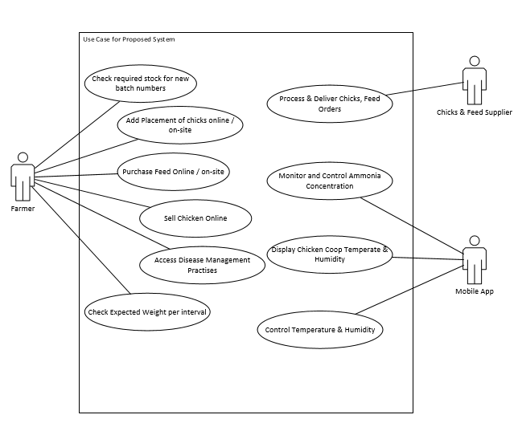

# Chapter 4: Design

## Solution Architecture

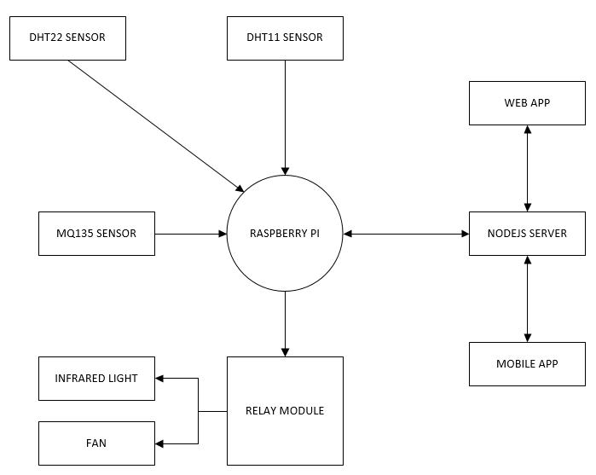

## Activity Diagram

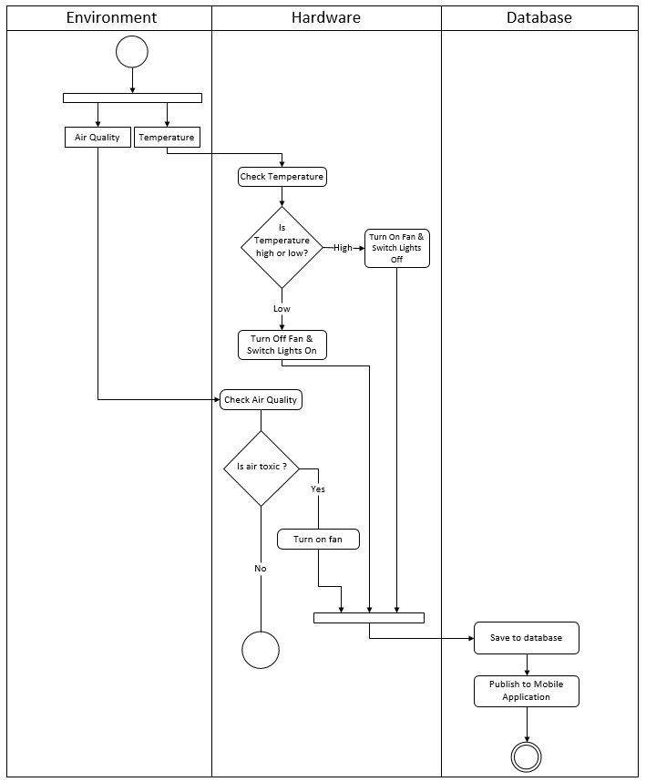

## ER Diagram

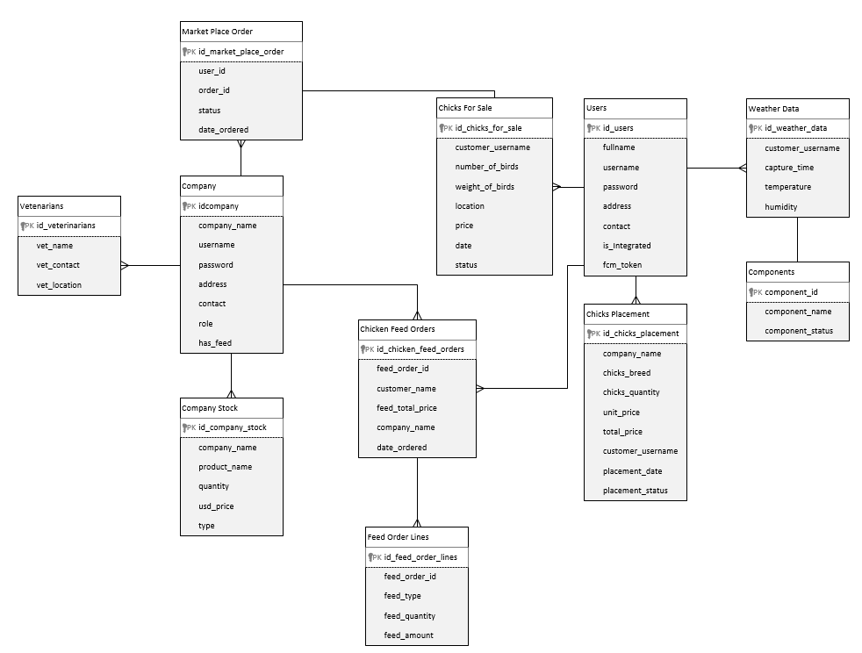

## Normalized Databases

### Users Table

|  |  |  |
| --- | --- | --- |
| **Column Name** | **Data Type** | **Description** |
| fullname | String | Full name of app user |
| Username | String | Username of app user |
| Password | String | Password for app user |
| Address | String | Address of app user |
| contact | Number | Contact of app user |
| Is_Integrated | Boolean | Flag to show usage of environment control equipment |
| Fcm_token | String | Firebase cloud messaging token (push notifications) |

### Company Table

|  |  |  |
| --- | --- | --- |
| **Column Name** | **Data Type** | **Description** |
| Company_name | String | Name of company |
| Username | String | Username of company |
| Password | String | Password of company |
| Address | String | Location of company |
| Contact | Number | Company line for calls |
| Role | String | Permission level of user |
| Has_feed | Boolean | Flag to show if company is feed supplier |

### Chicken Feed Orders Table

|  |  |  |
| --- | --- | --- |
| **Column Name** | **Data Type** | **Description** |
| id_chicken_feed_orders | Int | Total orders count tracker |
| Feed_order_id | String | Unique identifier for every order |
| Customer_name | String | Name of customer who ordered |
| Feed_total_price | Double | Total cost of feed order |
| Company_name | String | Company where customer is ordering from |
| Date_ordered | DateTime | Date when order was placed |

### Chicks Placement Table

|  |  |  |
| --- | --- | --- |
| **Column Name** | **Data Type** | **Description** |
| Id_chicks_placement | Int | Chicks Placement Count Tracker |
| Company_name | String | Name of company user is ordering from |
| Chicks_breed | String | Breed of ordered chicks |
| Chicks_quantity | Int | Number of ordered chicks |
| Unit_price | Double | Price of each chick of ordered breed |
| Total_price | Double | Total price of chicks order |
| Customer_username | String | Name of customer ordering |
| Placement_date | DateTime | Date of placement |
| Placement_status | String | Status of placement order |

### Chicks for Sale Table

|  |  |  |
| --- | --- | --- |
| **Column Name** | **Data Type** | **Description** |
| Id_chicks_for_sale | Int | Market Place Entry Count |
| customer_username | String | Name of selling customer |
| number_of_birds | Int | Number of birds being sold |
| weight_of_birds | Float | Total weight of birds being sold |
| Location | String | Where the chickens are located |
| Price | Double | Price per chicken |
| Date | DateTime | Date where order was sent to market place |
| status | String | Status of order on market place |

### Weather Data Table

|  |  |  |
| --- | --- | --- |
| **Column Name** | **Data Type** | **Description** |
| Id_weather_data | Int | Weather data entry count |
| Customer_username | String | Name of environment control owner |
| Capture_time | String | Time when weather data was captured |
| Temperature | Float | Temperature of coop |
| humidity | Float | Humidity inside coop |

### Veterinarians Table

|  |  |  |
| --- | --- | --- |
| **Column Name** | **Data Type** | **Description** |
| Id_veterinarians | Int | Veterinarians count tracker |
| Vet_name | Stirng | Name of veterinarian |
| Vet_contact | Number | Contact of veterinarian |
| Vet_location | String | Where the veterinarian is based |

### Company Stock Table

|  |  |  |
| --- | --- | --- |
| **Column Name** | **Data Type** | **Description** |
| Id_company_stock | Int | Stock count tracker |
| company_name | String | Name of company |
| Product_name | String | Name of stock item |
| Quantity | Int | Number of units of stock item |
| Usd_price | Double | USD Dollar price of stock item |
| type | String | Type of stock item |

### Components Table

|  |  |  |
| --- | --- | --- |
| **Column Name** | **Data Type** | **Description** |
| Component_id | Int | Unique identifier for hardware components |
| Component_name | String | Name of component |
| Component_status | Boolean | Current status of component either on or off |

### Market Place Order

|  |  |  |
| --- | --- | --- |
| **Column Name** | **Data Type** | **Description** |
| Id_market_place_order | Int | Market Place Order Count Tracker |
| User_id | String | Id of ordering customer |
| Order_id | String | Order ID customer is interested in |
| Status | String | Status of order processing |
| Date_ordered | DateTime | Date/Time when order was placed |

### Feed Order Lines

|  |  |  |
| --- | --- | --- |
| **Column Name** | **Data Type** | **Description** |
| Id_feed_order_lines | Inst | Feed order lines count tracker |
| Feed_order_id | String | ID of feed order |
| Feed_type | String | Type of feed ordered |
| Feed_quantity | Int | Number of feed stock item ordered |
| Feed-amount | Double | Total cost for stock item |

## Class Diagram

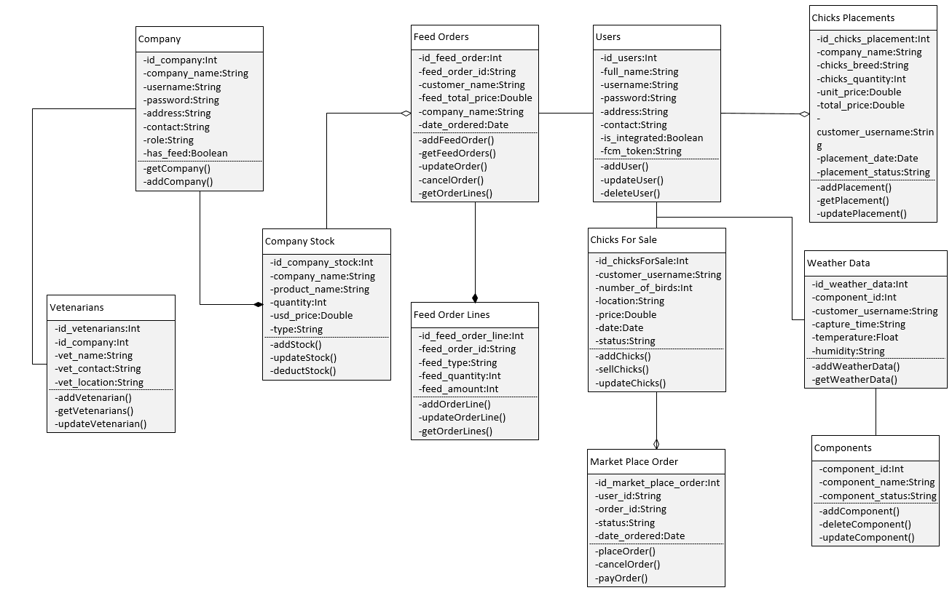

## Sequence Diagram

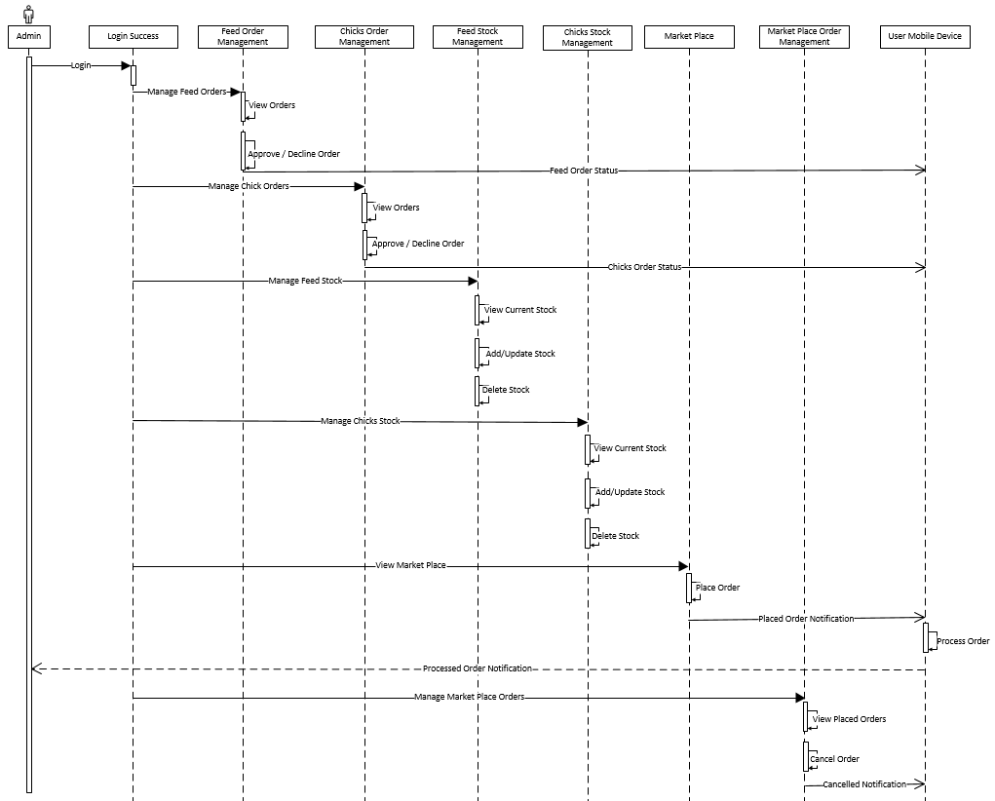

## Interface Design

### Web Portal for Suppliers

#### Home Page

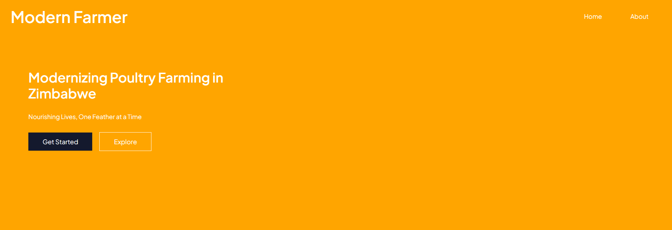

#### Dashboard

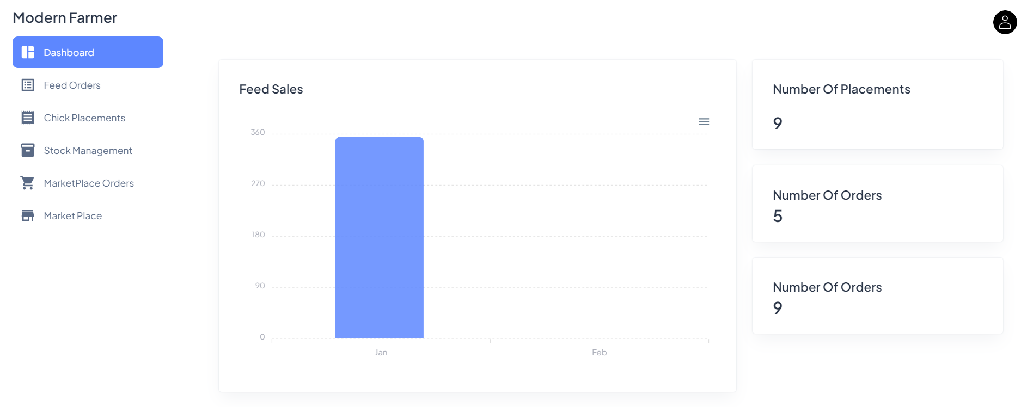

#### Feed Orders

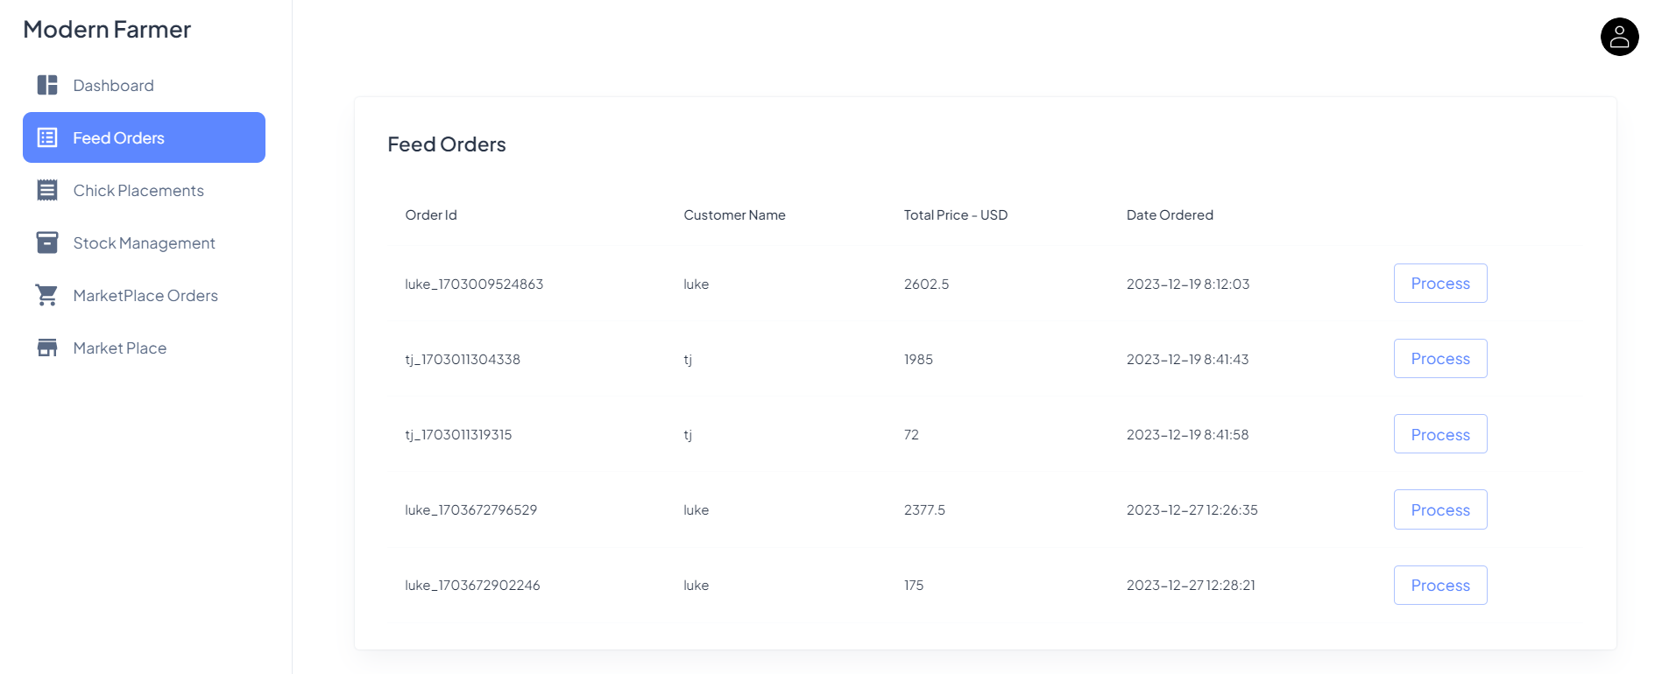

#### Chick Placements

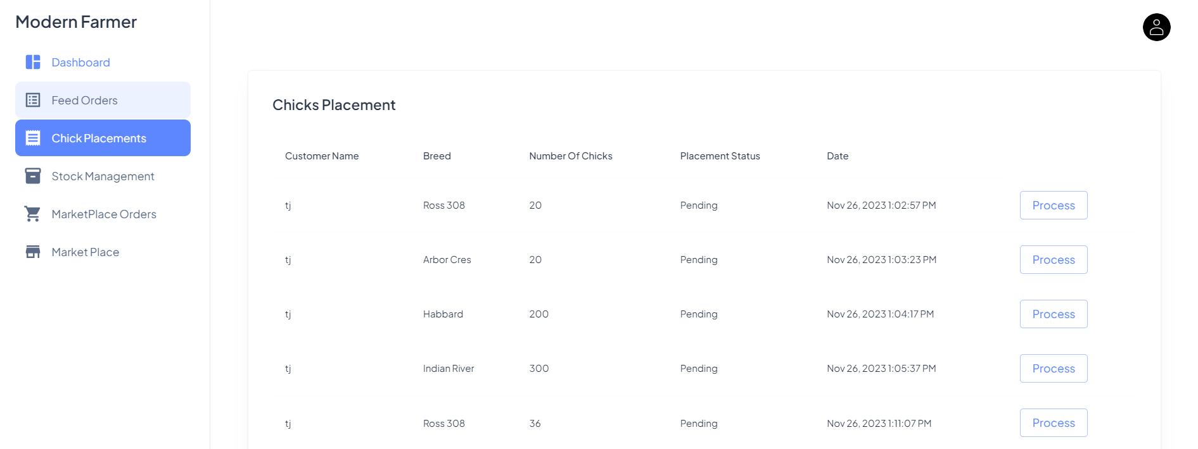

#### Stock Management

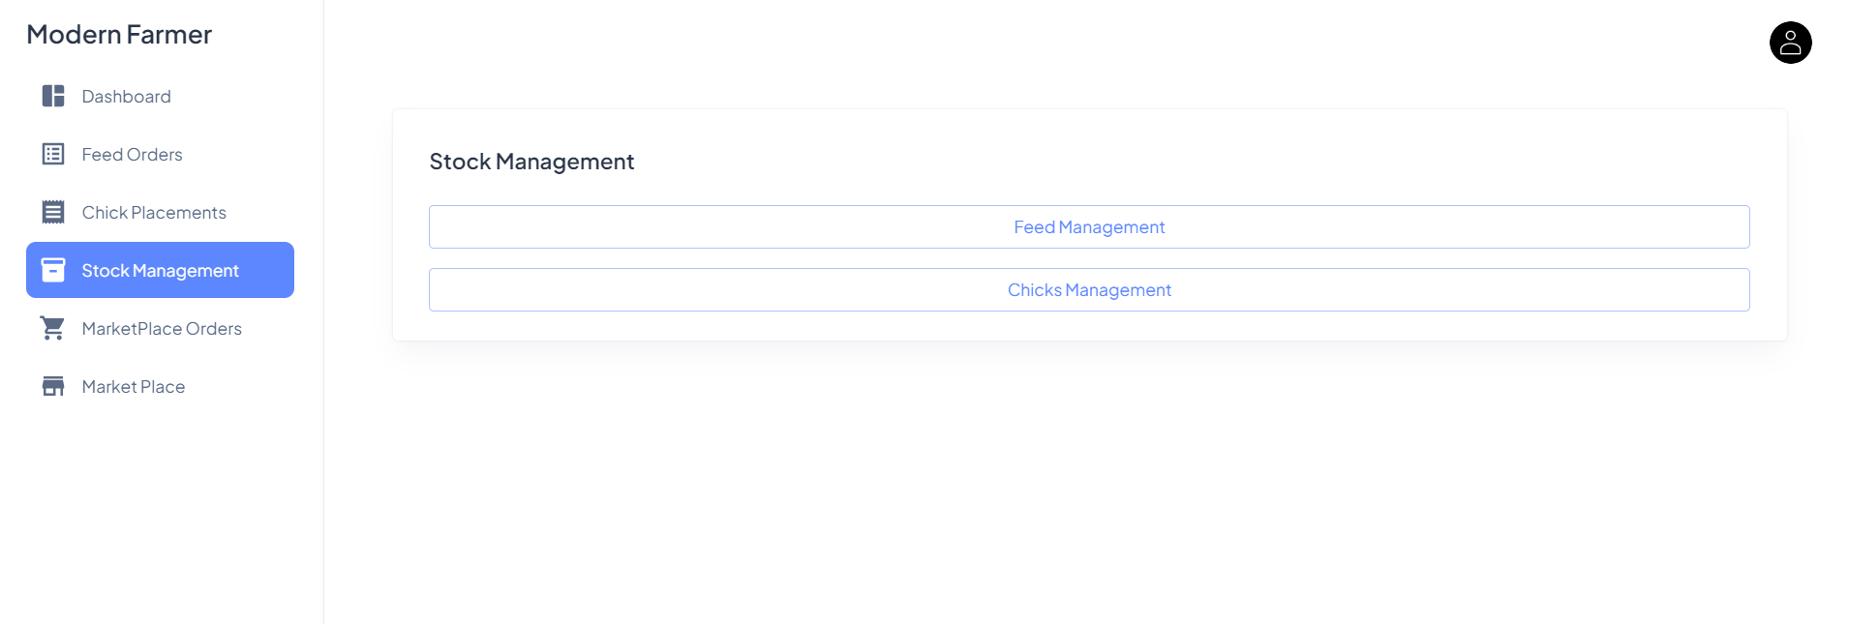

#### Feed Management

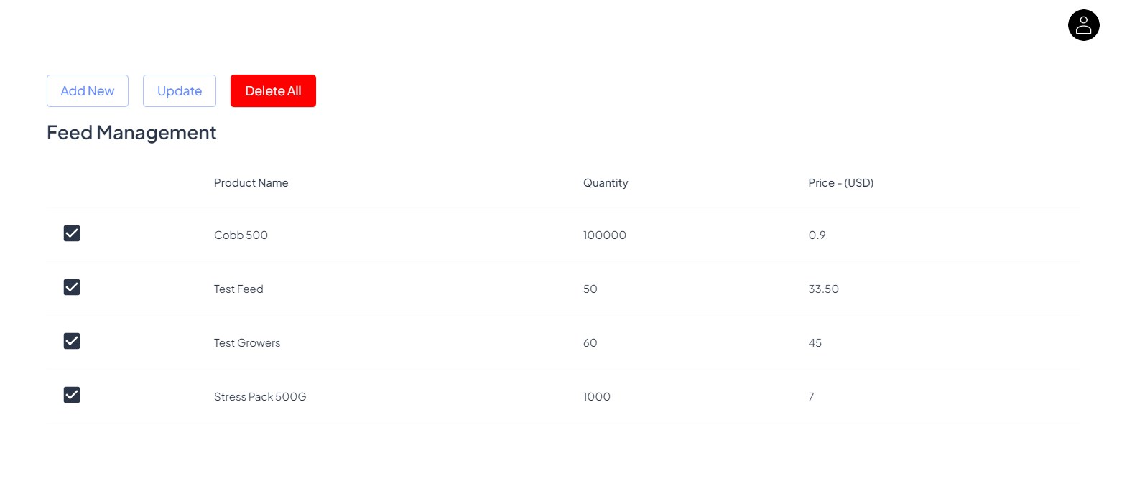

#### Add New Feed

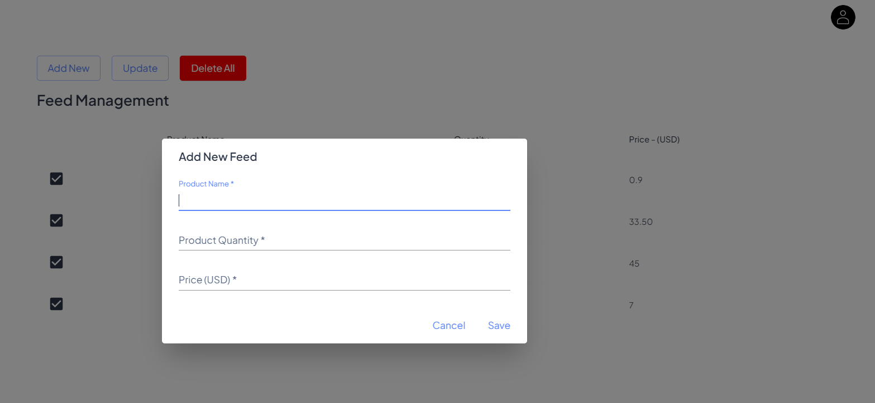

#### Chicks Management

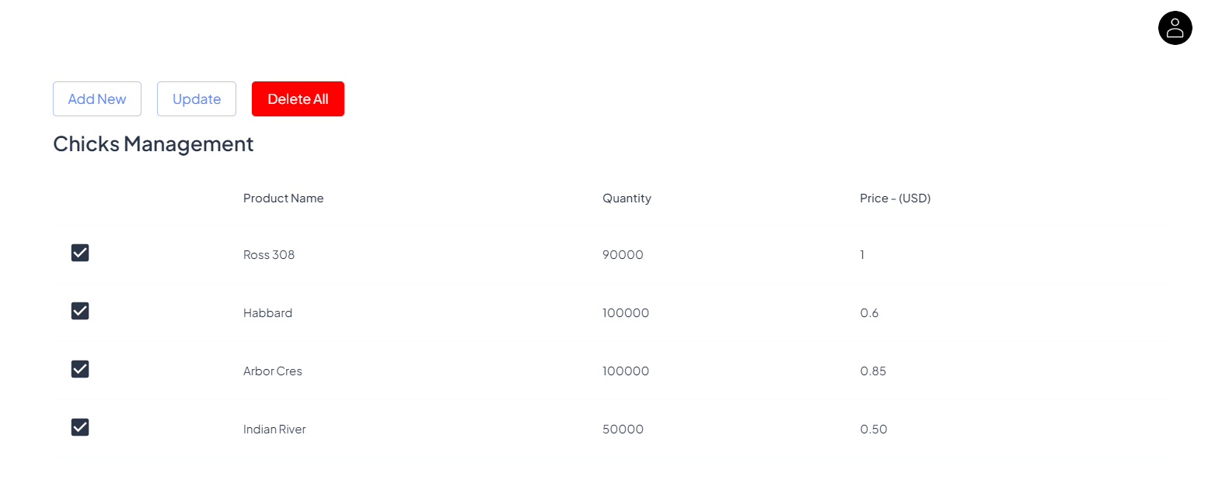

#### Add New Chicks

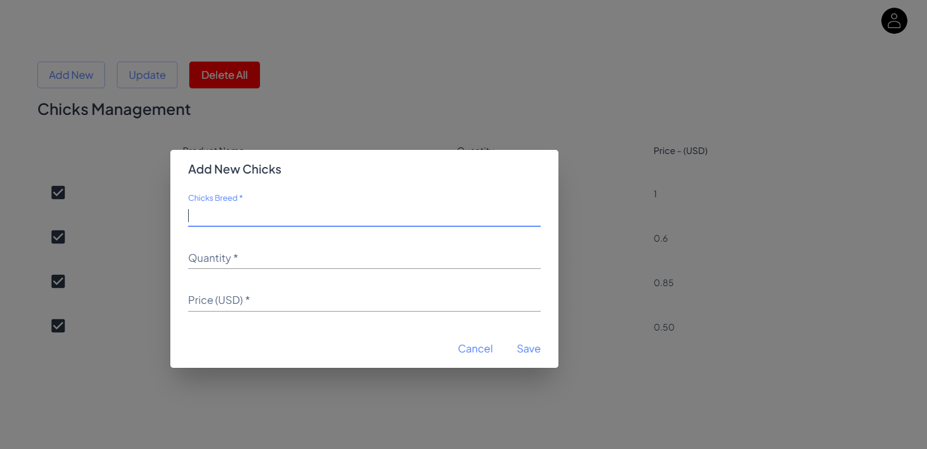

#### Market Place Orders

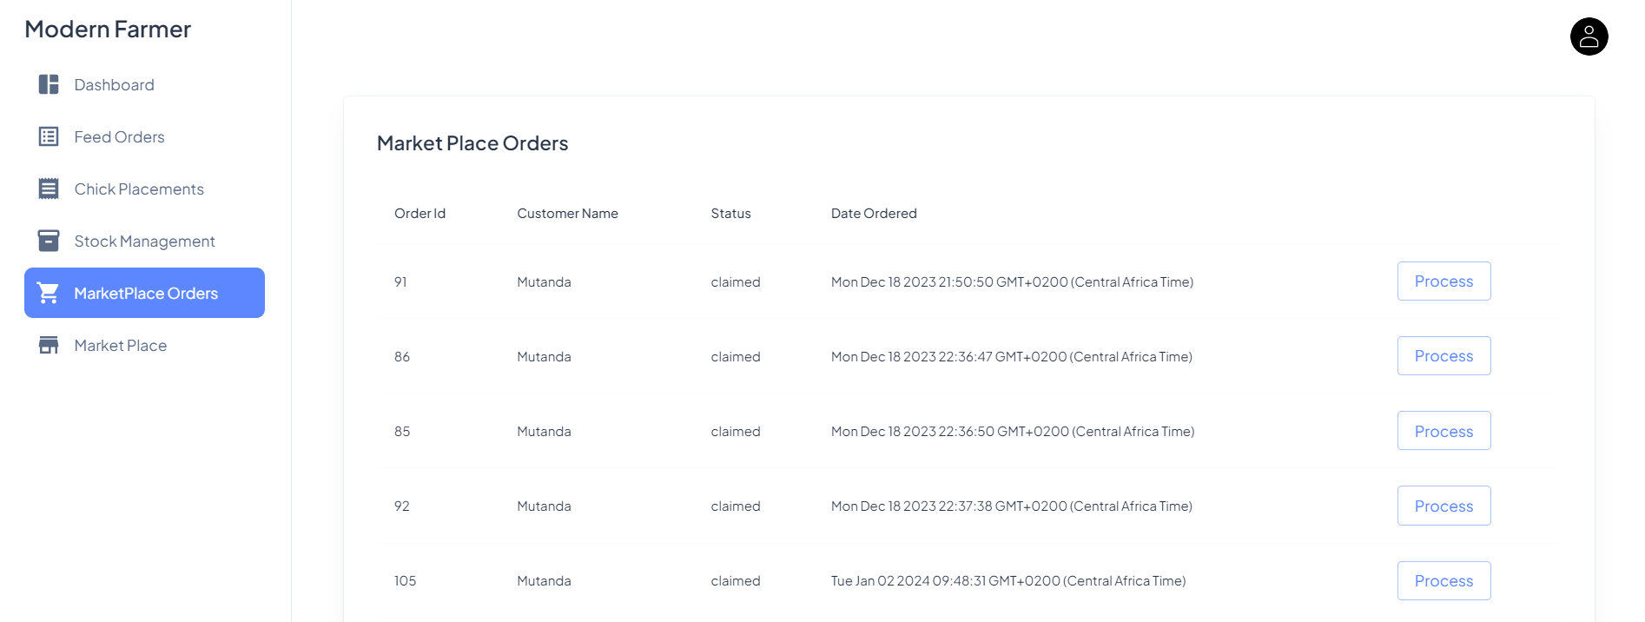

#### Market Place

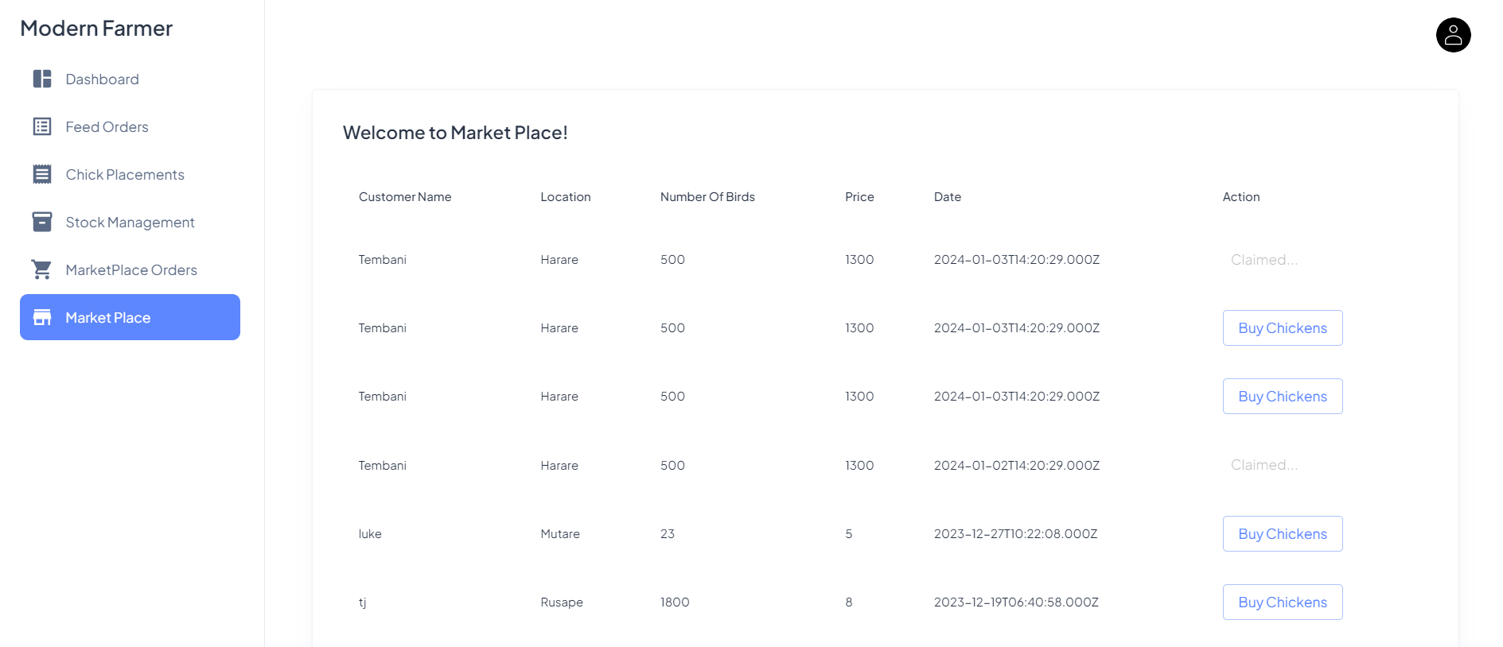

#### Sign In

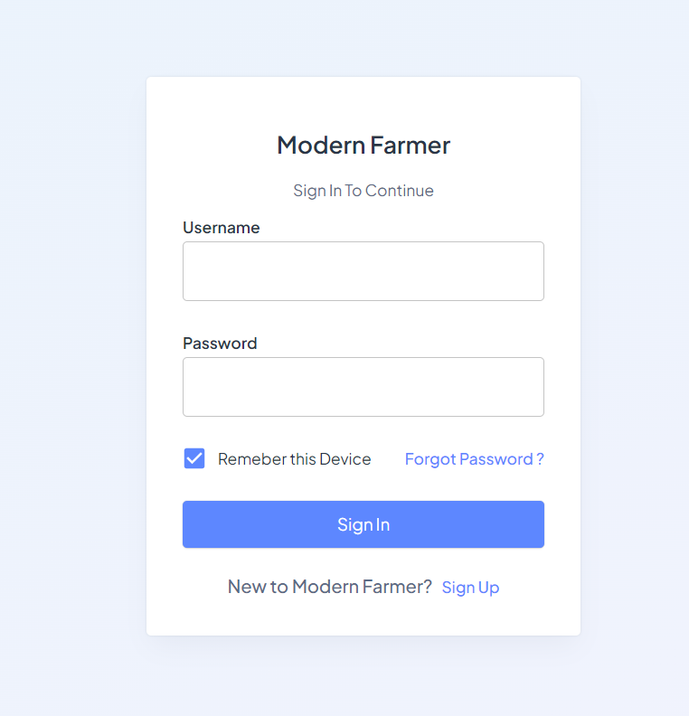

#### Sign Up

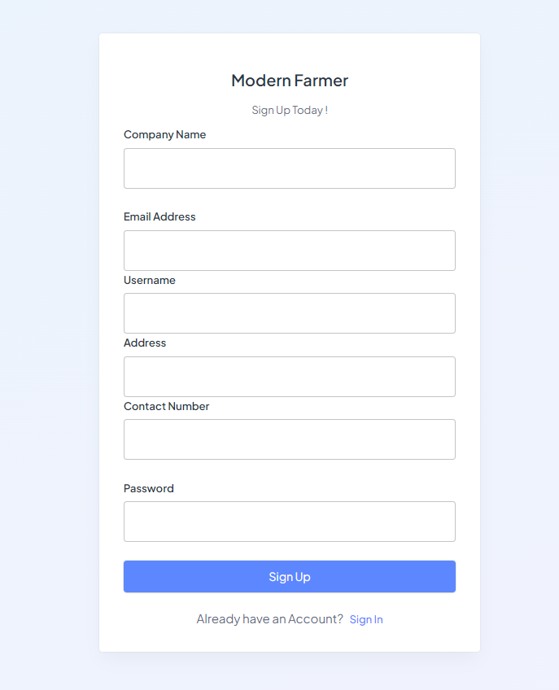

### Mobile App for Farmers

|  |  |  |
| --- | --- | --- |
| Login | Sign Up | Main Dashboard |
| Drawer Menu | Add Placement | Environment Control |
| Buy Feed | Claimed Orders | Veterinarians |

#### Hardware Component

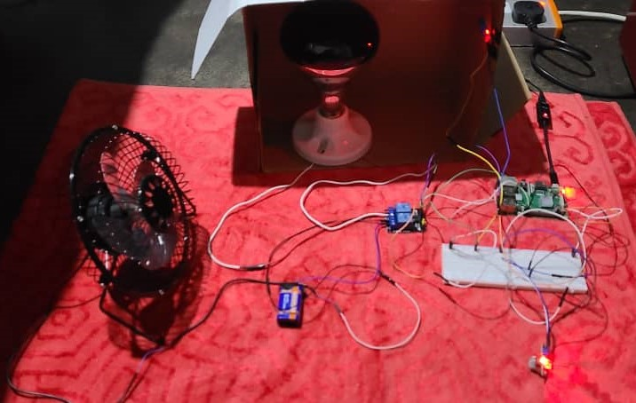

# Chapter 5: Implementation & Testing

## Code of Major Modules

### Raspberry PI Code

#### Relay Module API

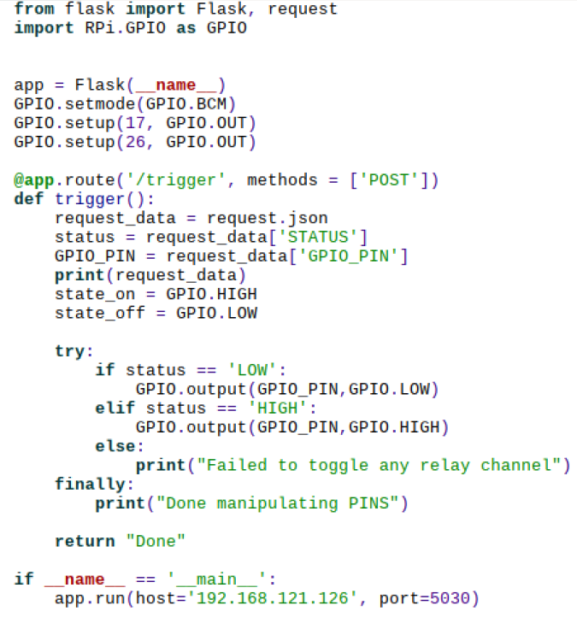

#### Temperature & Humidity Sender

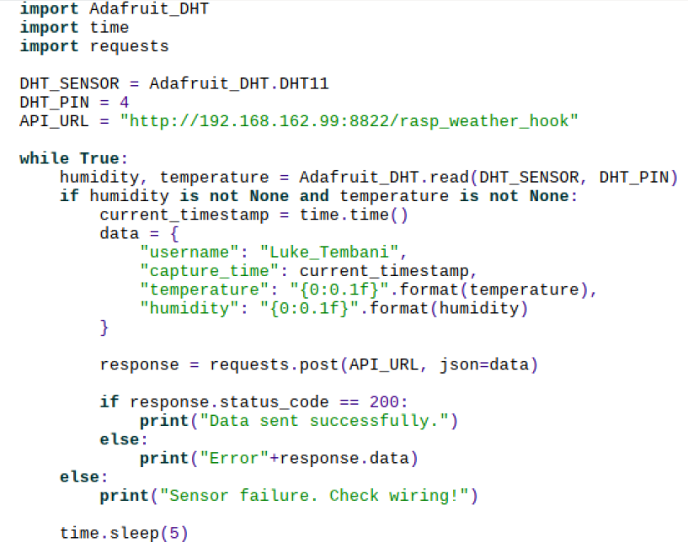

### NodeJs Backend Code

#### Raspberry PI Web hook

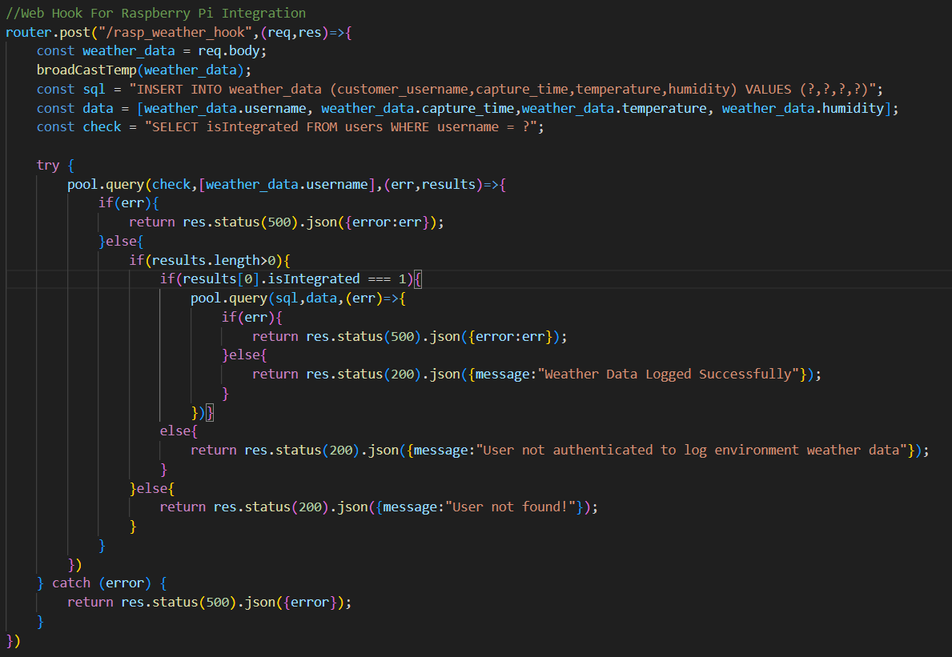

#### Temperature, Humidity, Gas Controller

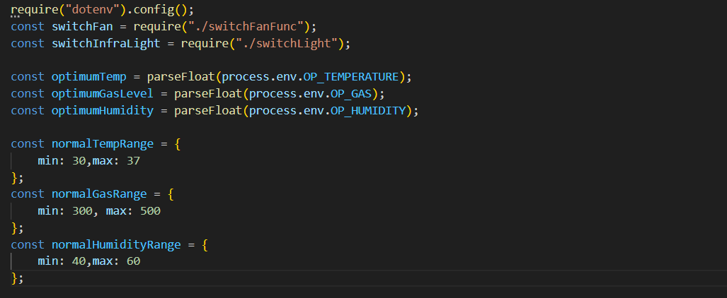

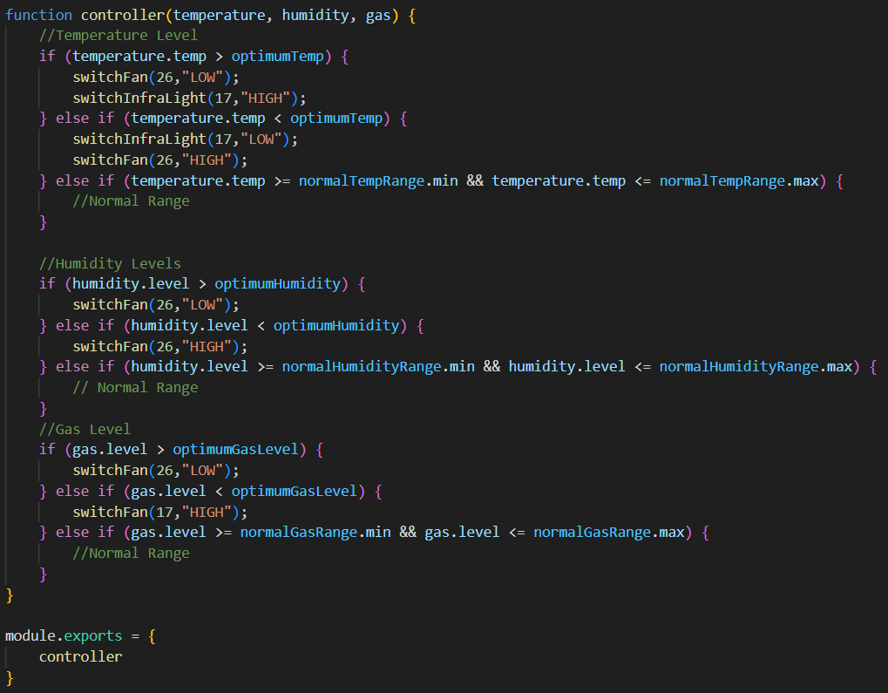

#### Firebase Push Notifications for Chicks Placements

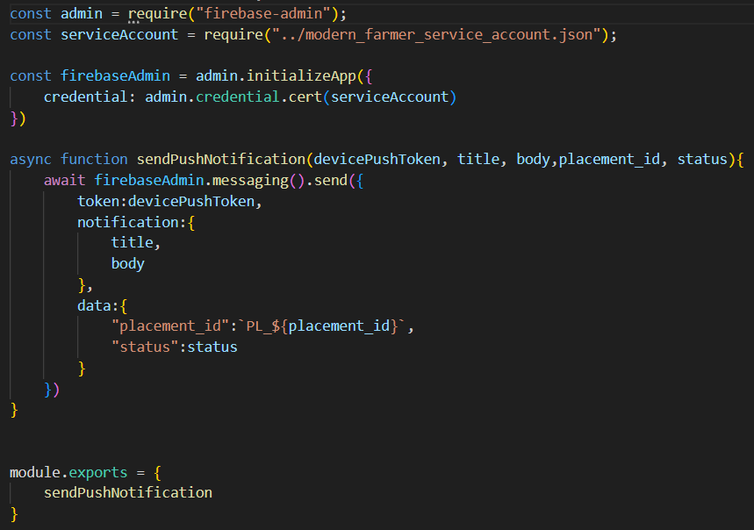

#### Add Feed Order API

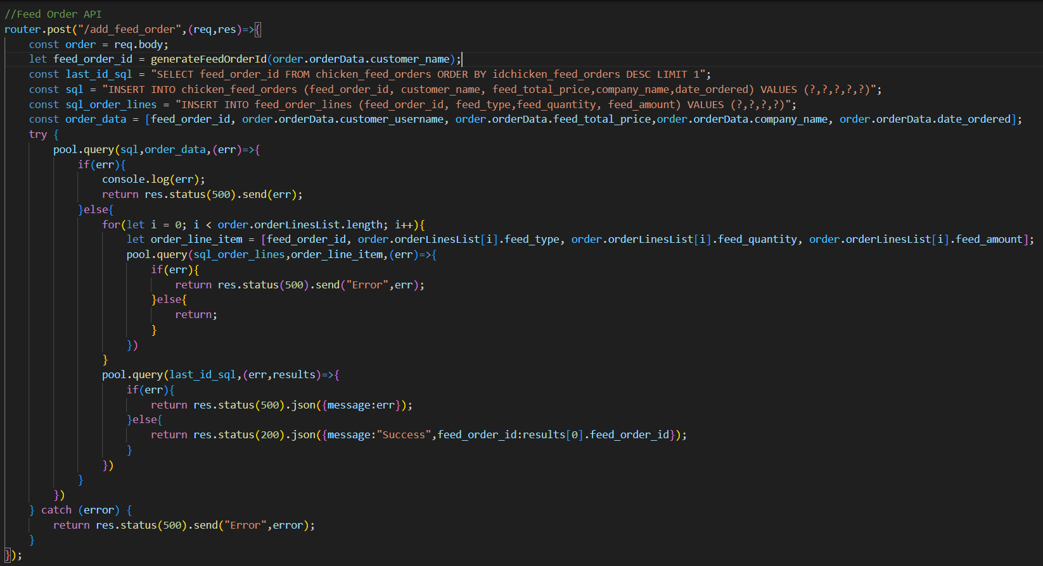

#### Web Sockets Implementation for Environmental Data & Chickens Market Place

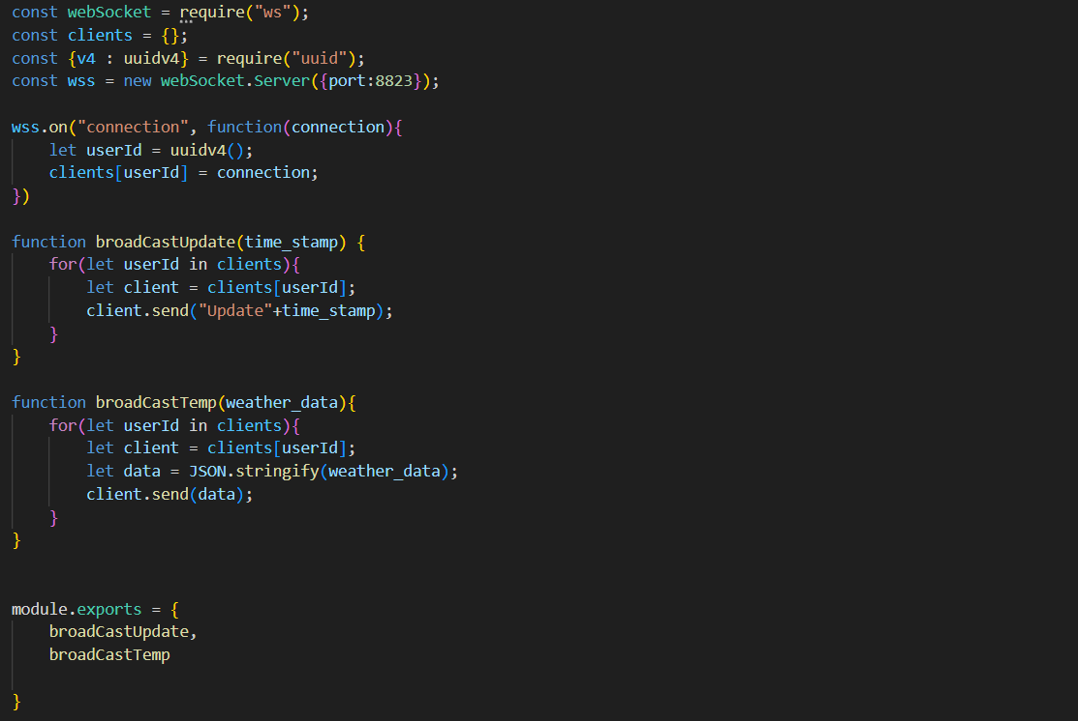

#### Company Update API

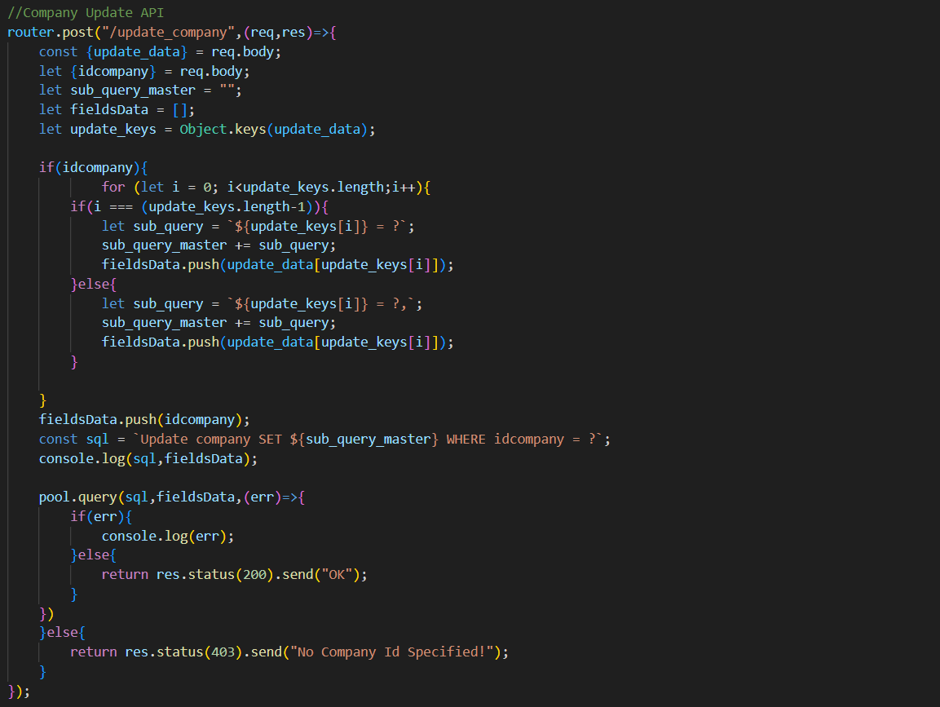

### React Frontend Code

#### Get Market Place Orders

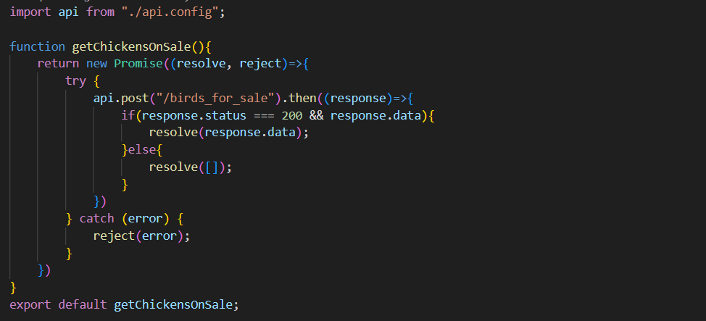

#### Updating Feed Order Status

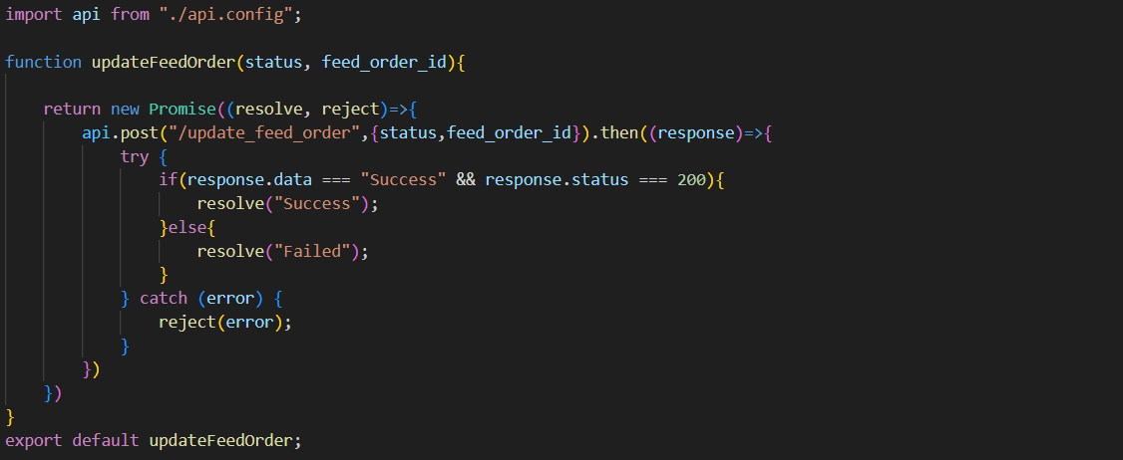

#### Market Place View

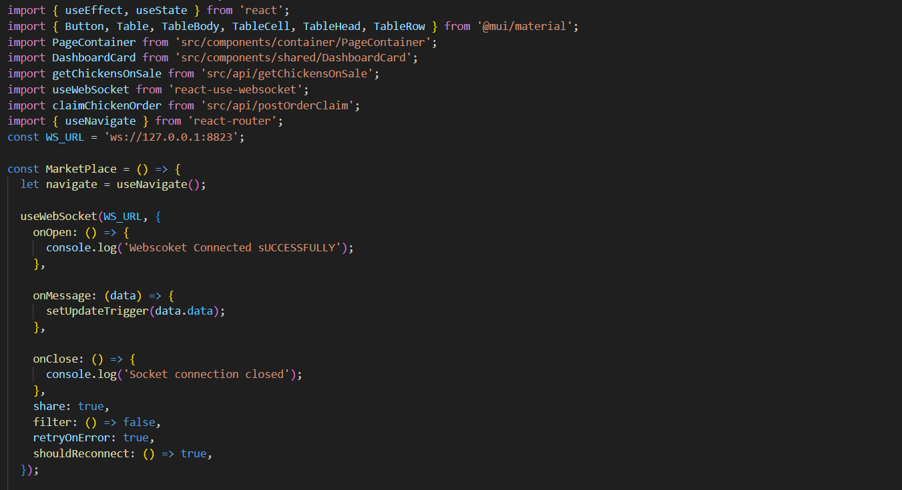

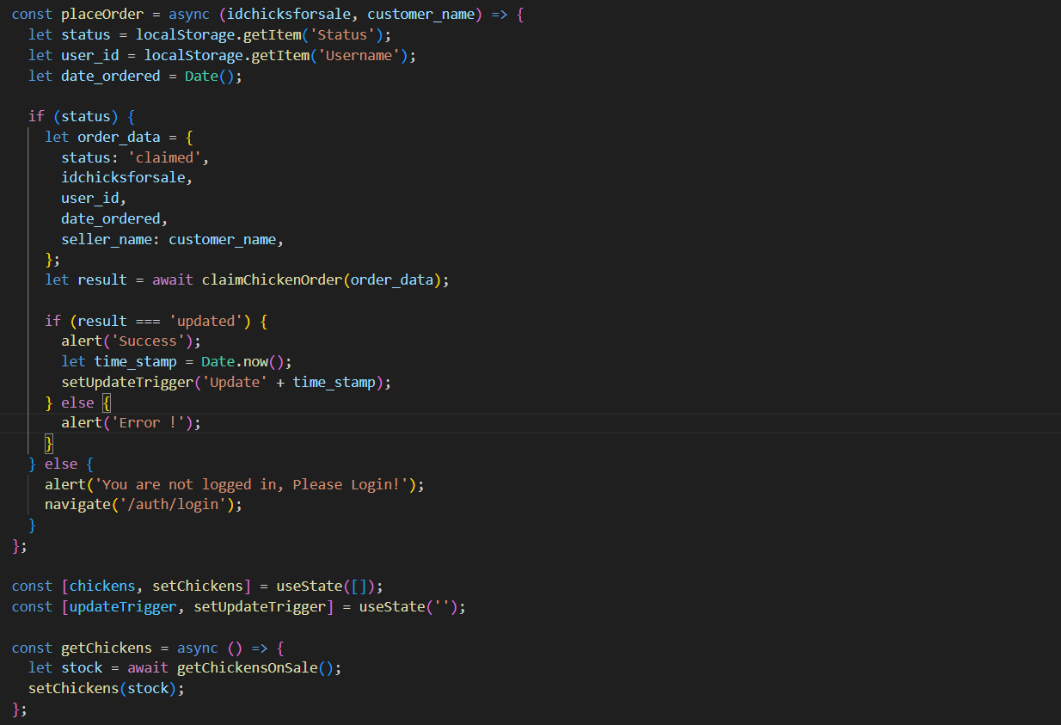

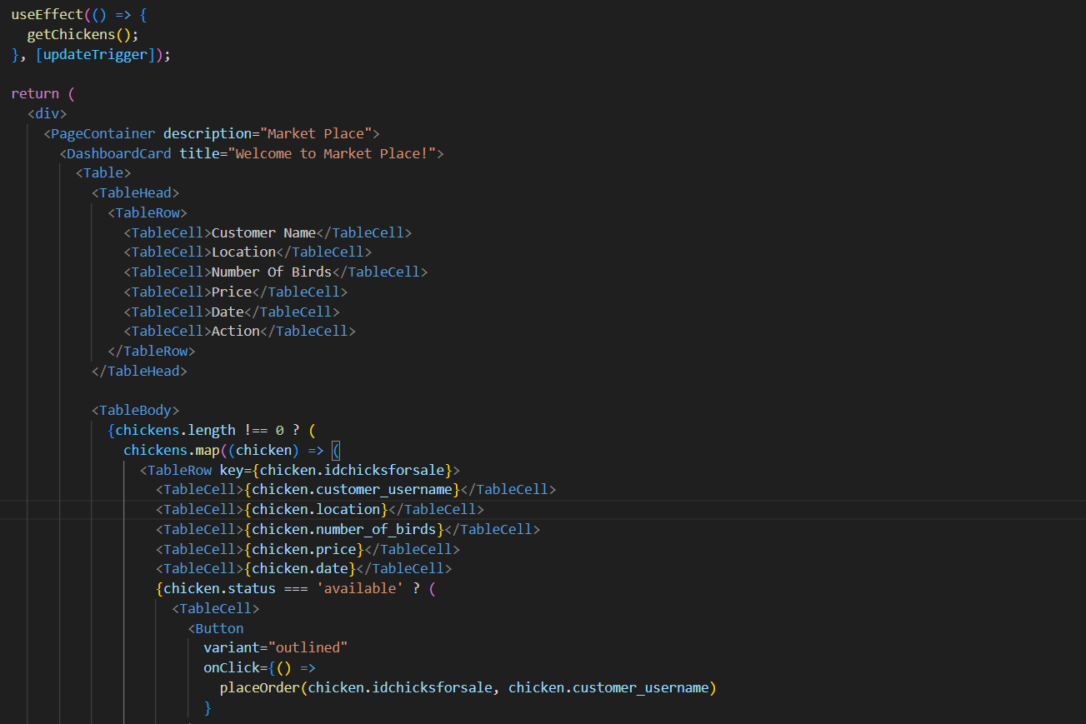

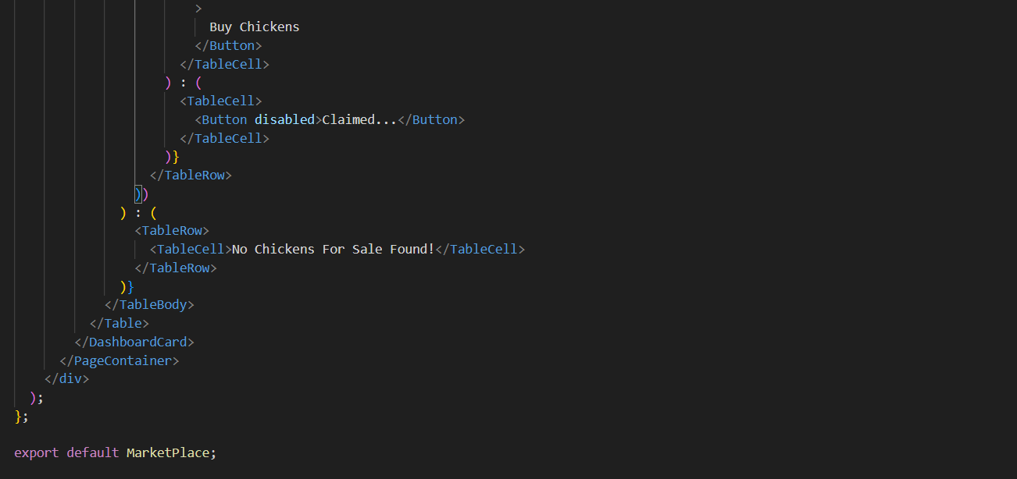

### Mobile Application Code (Java, Android)

#### Web Socket Client

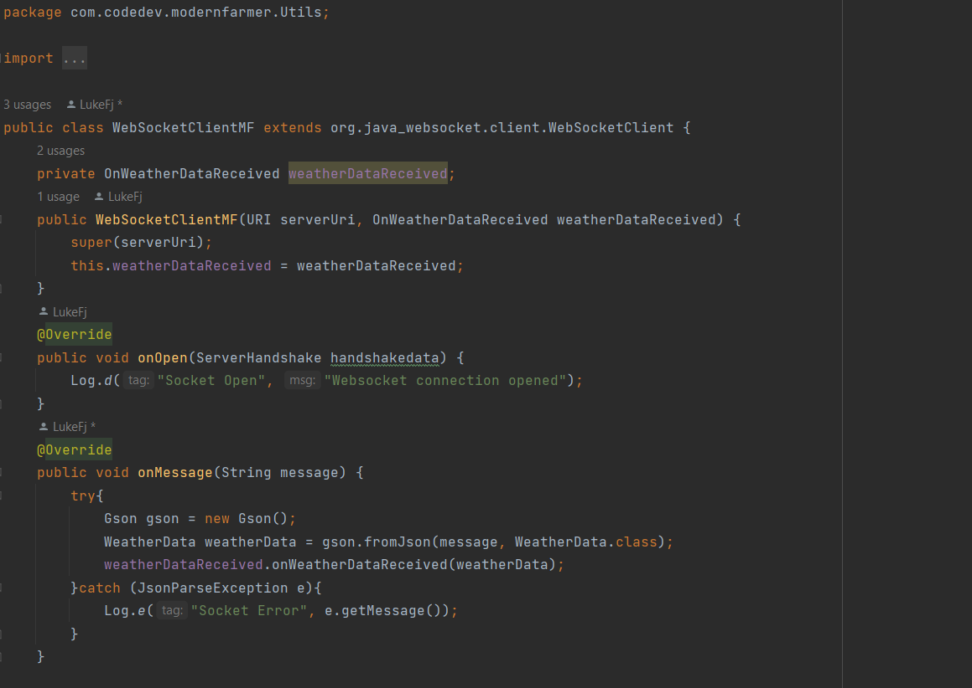

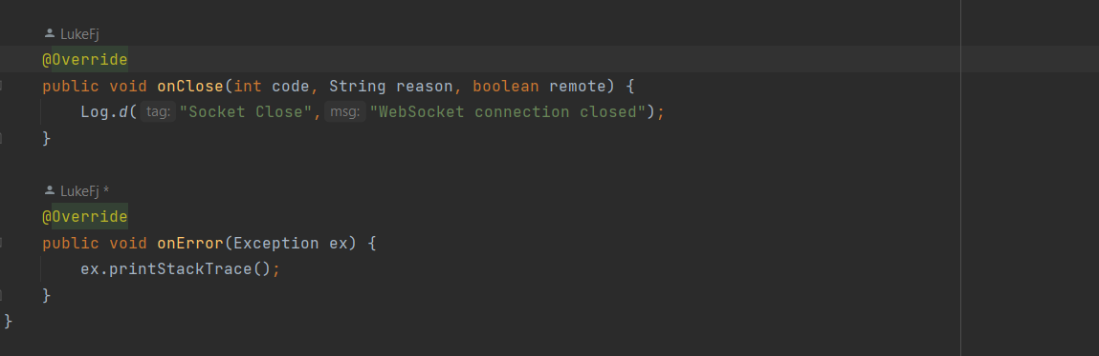

#### Selling Chickens Fragment

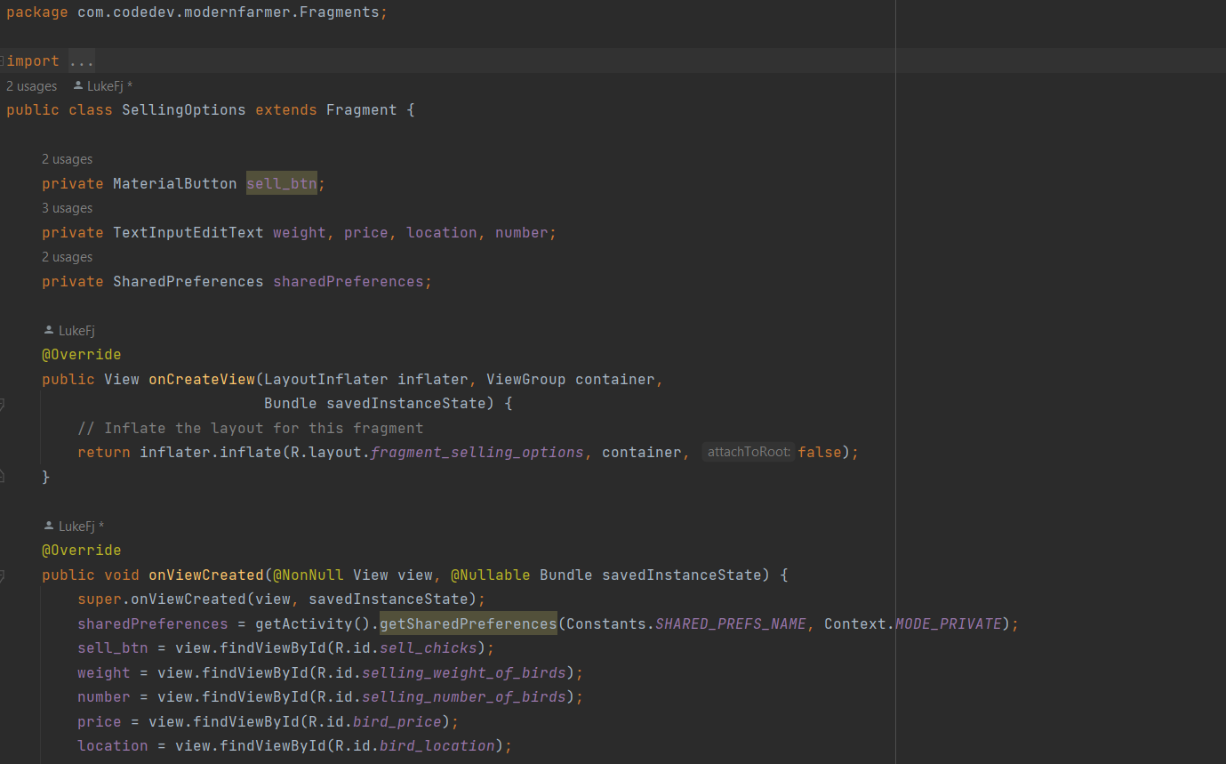

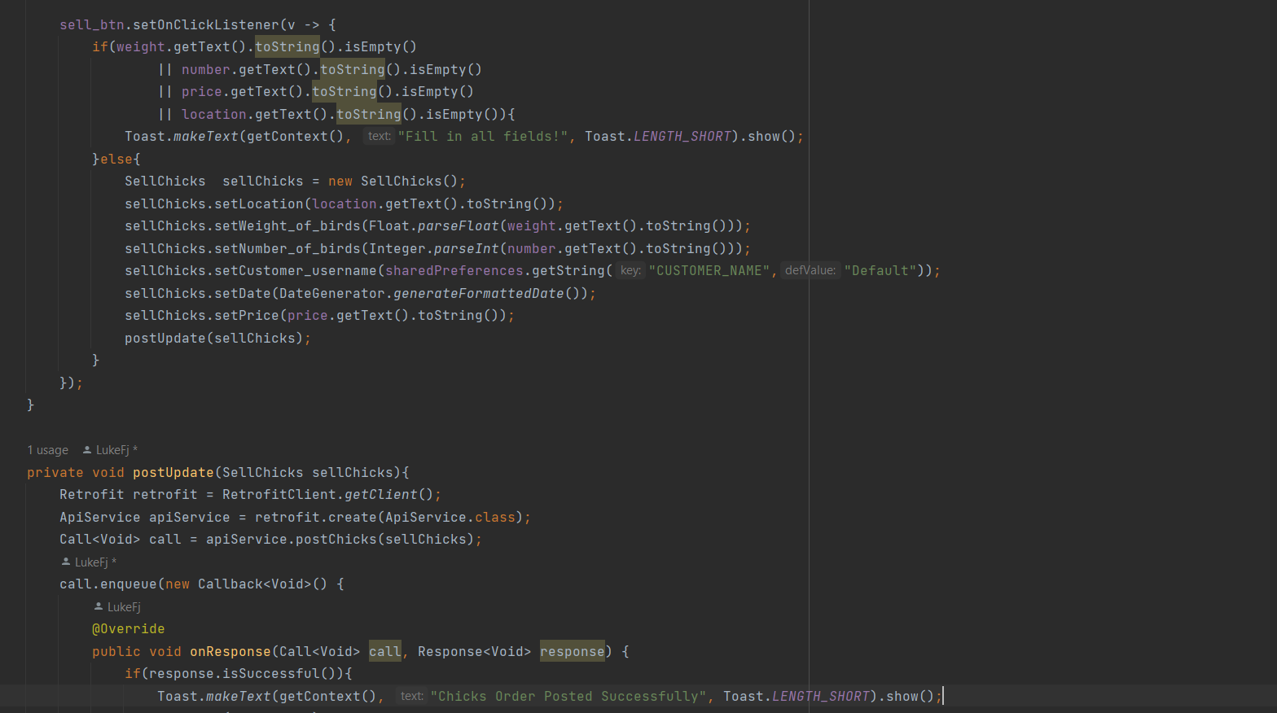

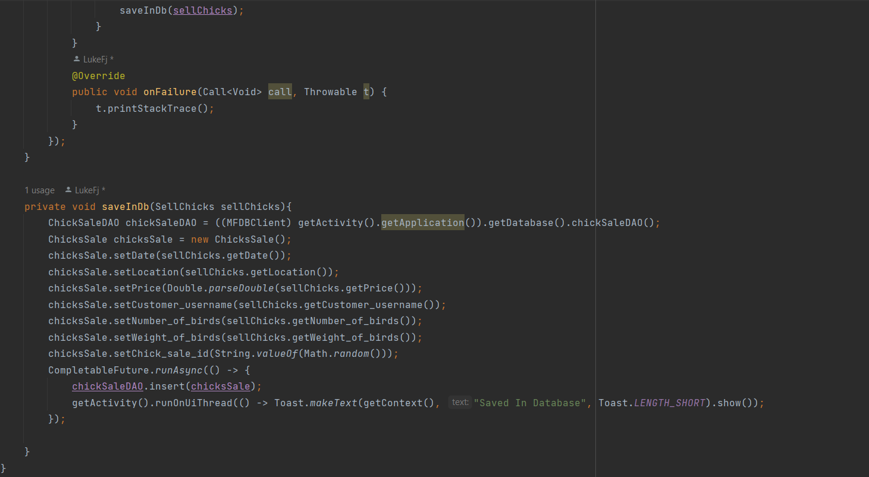

## Software Testing

### Unit

DTH11/22 Temperature Sensor

|  |  |  |
| --- | --- | --- |
| Test Case | Expected | Result |
| Lower Temperature | Temperature must go down | Temperature went down |
| Maintain constant temperature | Temperature should not change | Temperature didn’t change |
| Increase Temperature | Temperature goes Up | Temperature went up |

MQ135 Gas Sensor

|  |  |  |
| --- | --- | --- |
| Test Case | Expected | Result |
| Lower Temperature | Temperature must go down | Temperature went down |
| Maintain constant temperature | Temperature should not change | Temperature didn’t change |
| Increase Temperature | Temperature goes Up | Temperature went up |

### Module

|  |  |  |
| --- | --- | --- |
| Module Name | Test Description | Outcome |
| Temperature Sensor | Verify temperature sensor readings against a known temperature source. | Temperature readings within an acceptable margin of error. |
| Humidity Sensor | Test humidity sensor readings in various humidity environments. | Humidity readings within an acceptable margin of error. |
| Air Quality Sensor | Test air quality sensor readings by exposing it to different pollutants and gases. | Detection of pollutants and gases with reasonable accuracy. |
| Cooling Fan Control | Simulate temperature conditions above threshold and check if cooling fan turns on. | Cooling fan activates when temperature exceeds threshold. |
| Infrared Heating Control | Simulate temperature conditions below threshold and check if infrared heating turns on. | Infrared heating activates when temperature falls below threshold. |
| Mobile App | Test the display of temperature, humidity, and air quality data on the mobile app. | Accurate and timely display of sensor data on the mobile app. |
| Data Transmission | Verify the transmission of sensor data from the IoT component to the mobile app. | Sensor data transmitted accurately and reliably to the mobile app. |
| Notification Module | Test Firebase push notifications for order statuses, chick statuses, and payment notifications. | Users receive timely and accurate notifications via Firebase. |
| Web Portal Integration | Test integration between the web portal and Firebase for order management and notification delivery. | Orders and notifications are managed seamlessly via the web portal. |

### Integration

|  |  |  |
| --- | --- | --- |
| Integration Point | Test Description | Outcome |
| Sensors to Control Module Integration | Simulate sensor data transmission to the control module and verify if the control module responds appropriately. | Control module reacts correctly to sensor data, triggering actions based on thresholds. |
| Control Module to Mobile App Integration | Test the transmission of data from the control module to the mobile app and ensure that the mobile app displays the data accurately. | Mobile app receives and displays sensor data accurately and in real-time. |
| Web Portal to Firebase Integration | Verify that data from the web portal, such as orders and notifications, are correctly stored and delivered via Firebase. | Data from the web portal is stored accurately in Firebase and delivered to relevant recipients without delay. |
| Mobile App to Firebase Integration | Test the interaction between the mobile app and Firebase for push notifications and data synchronization. | Firebase push notifications are delivered to the mobile app users promptly and data synchronization is seamless. |
| Control Module to Cooling Fan/ Infrared Heating Integration | Simulate temperature conditions triggering control module actions and verify if cooling fans and heating elements are activated or deactivated accordingly. | Cooling fans and heating elements respond correctly to temperature changes as per control module instructions. |
| Mobile App to Web Portal Integration | Send test orders from the mobile app for supplies such as chicks and feed and verify if they are correctly received and displayed on the web portal. | Orders for supplies made from the mobile app are accurately reflected on the web portal for further processing. |

### System

|  |  |  |
| --- | --- | --- |
| System Aspect | Test Description | Outcome |
| Overall System Functionality | Conduct end-to-end testing of the entire system, including sensor data collection, control module actions, data transmission to the mobile app, and notification delivery. | The entire system functions as expected without any critical issues. |
| Load Testing | Simulate high loads on the system to ensure it can handle peak usage scenarios without crashing or slowing down. | The system maintains acceptable performance levels under varying loads. |
| Data Accuracy and Reliability | Verify the accuracy and reliability of sensor data collection, transmission, and display on the mobile app. | Sensor data is accurately captured, transmitted, and displayed in real-time. |
| Notification Delivery | Test the delivery of Firebase push notifications for different events such as order statuses and chick statuses. | Users receive timely and accurate notifications via Firebase. |
| Integration between Modules and External Systems | Test the integration between different modules within the system and external systems such as Firebase and the web portal. | Data is seamlessly exchanged between modules and external systems. |
| Error Handling and Fault Tolerance | Introduce various error scenarios such as network failures or sensor malfunctions and verify how the system handles them. | The system gracefully handles errors and maintains its core functionality. |
| Compatibility Testing | Test the system across different devices and platforms to ensure compatibility with various mobile devices and web browsers. | The system functions correctly on a wide range of devices and browsers. |

### Database

|  |  |  |
| --- | --- | --- |
| Database Aspect | Test Description | Outcome |
| Data Integrity | Verify that data stored in the database is accurate and consistent by inserting, updating, and querying records. | Data remains consistent and accurate throughout various database operations. |
| Data Retrieval | Test the efficiency and accuracy of data retrieval operations by querying the database with different parameters. | Data is retrieved accurately and efficiently without any significant delays. |
| Backup and Restore | Test the backup and restore functionality of the database to ensure data can be reliably backed up and restored. | Data can be backed up and restored without loss or corruption. |
| Data Storage Capacity | Simulate a large volume of data to verify that the database can handle the expected amount of data without performance degradation. | The database can accommodate the expected data volume without significant slowdowns. |
| Concurrent Access Control | Test the database's ability to handle concurrent access by multiple users or processes without data corruption or conflicts. | Concurrent access does not result in data corruption or conflicts. |

### Acceptance

|  |  |  |
| --- | --- | --- |
| Aspect of Acceptance Testing | Test Description | Outcome |
| User Interface | Evaluate the usability and intuitiveness of the mobile app and web portal interfaces. | Users find the interfaces easy to navigate and understand. |
| Functional Requirements | Test whether the system meets the specified functional requirements as outlined in the project scope. | The system fulfils all specified functional requirements without errors. |
| Usability Testing | Assess the overall user experience of interacting with the system, focusing on ease of use and user satisfaction. | Users can perform tasks efficiently and are satisfied with the system's performance. |
| Compatibility Testing | Test the system across different devices and platforms to ensure compatibility with various mobile devices and web browsers. | The system functions correctly on a wide range of devices and browsers. |
| Performance Testing | Evaluate the system's performance under normal and peak loads to ensure it can handle expected user traffic. | The system maintains acceptable performance levels under varying loads. |
| Security Testing | Verify that the system has appropriate security measures in place to protect user data and prevent unauthorized access. | User data is securely stored and transmitted, and access controls are effective. |
| Regulatory Compliance Testing | Ensure that the system complies with relevant regulatory standards and requirements, such as data privacy regulations. | The system adheres to all applicable regulatory standards and requirements. |

# Chapter 6: Conclusions and Recommendations

## Summary

The Modern Farmer Smart Poultry Management System, integrated with IoT, has been successfully designed, tested, and implemented. This innovative system addresses the challenges that poultry farmers face, including limited access to critical information, unreliable chick supply chains, difficulties in disease management, and opaque market dynamics. Collectively, these issues hinder the growth of the poultry industry and impede the economic prosperity of local farmers. The Modern Farmer system is a resounding success, providing farmers with access to poultry-related information, reliable chick and feed supply chains, and an automated chicken coop environment monitor that operates without human intervention. Additionally, it offers a broad marketplace for farmers to efficiently sell their produce. But that's not all—Modern Farmer also includes an intuitive dashboard for poultry suppliers to manage their inventory and conduct sales transactions. The system features real-time notifications to streamline feed and chick orders management and keep all relevant parties updated on the status of their sales orders.  
  
Findings  
During the course of the project, several key discoveries were made that have significant implications for the functionality and effectiveness of the Modern Farmer Smart Poultry Management System:

* It was observed that Firebase notifications cannot be delivered to devices that are offline. However, an important feature was discovered where these notifications are kept in a queue. This means that when a target device, which was previously offline, comes online, notifications are automatically sent, ensuring timely delivery of important messages.
* The DHT11/22 temperature sensors proved to be accurate in reading temperature. However, it was noted that like any other sensor, they require correct calibration for optimal performance. Additionally, these sensors exhibit a tendency to take time to adjust to the actual temperature, especially when exposed to very high temperatures.
* Web sockets were successfully implemented on the marketplace platform. This ensures that when an order is taken, it is immediately removed from the listing of all users. This prevents the scenario where one order is claimed by multiple users simultaneously, streamlining the order management process.
* The MQ135 temperature sensor was found to be highly accurate in detecting air quality and pollutants. However, it was discovered that proper calibration is crucial for accurate detection. It was recommended to calibrate the sensor by exposing it to clear air for 48 hours before actual use to ensure optimal performance.
* The automated control of coop environment parameters such as temperature and humidity proved to be immensely beneficial. This implementation eliminates the need for human intervention and greatly reduces the risk of human error. Quick adjustments, such as regulating temperature to acceptable thresholds, are crucial in poultry farming, making automation a significant advantage.
* Allowing suppliers to sell their produce online through the marketplace was found to modernize and streamline the supply chain process. This enables farmers to focus on poultry farming while eliminating the hassle of sourcing chicks and feed from reliable and affordable sources.

## Limitations

* The system heavily relies on technology, particularly IoT devices and connectivity. Any technical issues, such as network outages or hardware malfunctions, could disrupt operations and impact the system's functionality.
* Proper calibration and maintenance of sensors, such as temperature and air quality sensors, are essential for accurate data collection. Failure to regularly calibrate and maintain these sensors could lead to inaccurate readings and affect the system's effectiveness.
* The system requires a stable internet connection for real-time data transmission and communication with the mobile app and web portal. In areas with unreliable or limited internet access, users may experience difficulties in accessing and utilizing the system effectively.
* Implementing the Modern Farmer system involves upfront costs for purchasing IoT devices, developing software applications, and integrating various components. The initial investment may be prohibitive for small-scale farmers or those with limited financial resources.
* The success of the system relies on user adoption and proficiency in using the mobile app, web portal, and IoT devices. Farmers may require training and support to fully understand and utilize all features of the system, which could pose challenges in adoption, particularly among older or less tech-savvy users.

## Recommendations

* Implement regular monitoring and maintenance protocols for all system components, including IoT devices and software applications. This ensures optimal performance, accuracy of data, and longevity of the system.
* Provide comprehensive training and ongoing support to users, including farmers and suppliers, to maximize adoption and utilization of the system. Offer user-friendly guides, tutorials, and troubleshooting resources to address any challenges encountered.
* Explore alternative connectivity solutions, such as satellite internet or mesh networking, to overcome challenges related to internet connectivity in remote areas. This ensures seamless data transmission and communication regardless of location.
* Design the system with scalability and flexibility in mind to accommodate future growth and evolving needs of poultry farmers. Allow for easy integration of additional features, expansion of sensor networks, and adaptation to changing agricultural practices.
* Prioritize data security and privacy measures to protect sensitive information collected and stored by the system. Implement robust encryption protocols, access controls, and data anonymization techniques to safeguard user data against unauthorized access or breaches.

## Future Works

* Integration with Automated Feeding Systems: Explore the integration of automated feeding systems with the poultry management system. This would enable precise control over feed quantity and distribution based on real-time data, optimizing feed utilization and minimizing wastage.
* Development of Decision Support Tools: Develop decision support tools based on machine learning algorithms to assist farmers in making informed decisions related to poultry management. These tools could provide recommendations for optimizing feed formulation, disease management, and breeding programs based on historical data and predictive analytics.
* Expansion to Other Livestock: Consider expanding the scope of the poultry management system to include other types of livestock, such as pigs or cattle. Develop features tailored to the specific needs and requirements of different livestock species, enabling a comprehensive livestock management solution.
* Implementation of Predictive Maintenance: Develop predictive maintenance algorithms to anticipate potential failures in IoT devices, such as sensors and actuators, before they occur. This proactive approach helps prevent downtime and ensures continuous operation of the poultry management system.
* Development of Mobile Diagnostic Tools: Develop mobile diagnostic tools and applications that allow farmers to conduct basic health assessments and diagnostics on their poultry flock. This would empower farmers to identify and address potential health issues early on, reducing the risk of disease outbreaks and improving overall flock management.
* Continuous User Feedback and Iteration: Establish a mechanism for collecting continuous feedback from users and stakeholders, and use this feedback to inform iterative improvements and updates to the poultry management system. This iterative approach ensures that the system remains relevant and responsive to the evolving needs of poultry farmers.

## Conclusion

In conclusion, the Modern Farmer Smart Poultry Management System represents a promising solution to the challenges faced by poultry farmers, offering a pathway towards a more sustainable and efficient future for poultry farming. With ongoing development and refinement, the system has the potential to revolutionize poultry farming practices and contribute to the economic prosperity of farmers and communities worldwide.

# References

[1] Archana M P1, Uma S K2, “Monitoring and controlling of poultry farm using IOT”, International Journal of Innovative Research in Computer and Communication Engineering, Vol. 6, Issue 4, April 2018.

[2] Zainal H. C. Soh1, Mohd H. Ismail1, “Developement of automatic chicken feeder using Arduino Uno”,IEEE, Dec 2017.

[3] Danar Wicaksono, Ratna Mayasari, “Design and Analysis Automatic Temperature control in the Broiler poultry farm based on wireless sensor network”, 2nd International Conferences on Information Technology, Information Systems and Electrical Engineering (ICITISEE), Nov 2017.

[4] Raghudathesh G P1, Deepak D J2“IOT based intelligent poultry management system using Linux embedded system”, IEEE, Aug 2017.

[5]. Geetanjali A. Choukidar, Prof. N.A. Dawande, “Smart poultry farm automation and monitoring system”, IEEE, June 2017.

[6]. Ayyappan.V, Deepika.T, “Smart poultry farm automation and monitoring system”, IOT Based Smart Poultry Farm, South Asian Journal of Engineering and Technology Vol.3, No.2 (2017) 77– 84,07/03/2017

[7] Zhang H, Li J, Wen B, Xun Y, Liu J. Connecting Intelligent Things in Smart Hospitals Using NB-IoT. IEEE Internet of Things Journal. 2018; 5(3): 1550-1560.

[8] Shyam GK, Manvi SS, Bharti P. Smart waste management using Internet-of-Things (IoT). In the Proceedings of the 2nd International Conference on Computing and Communications Technologies (ICCCT). Chennai. 2017: 199-203.

[9] UpSkill Learning. ESP8266: Get Started with ESP8266 Programming NodeMCU Using Arduino IDE. First Edition. CreateSpace Independent Publishing Platform. 2016.

[10] Sipani JP, Patel RH, Upadhyaya T. Temperature and Humidity Monitoring & Control System Based on Arduino and SIM900A GSM Shield. International Journal of Electrical, Electronics and Data Communication. 2017; 5(11): 62-68.

[11] Osaretin CA, Edeko FO. Design and Implementation of Solar Charge Controller with Variable Output. Journal of Electrical and Electronics Engineering. 2016; 12(2): 40-52.

[12] Kamar I, Hamie A, Parag C. Internet of Things in Learning Systems - A Perspective of Platforms. International Journal of Advanced Research in Computer Science. 2016; 7(2): 52-56.

[13] https://www.fivetanimalhealth.com/products/kruuse-digital-thermometer-digi-vet-sc-12

[14] Mohannad Ibrahim, Abdelghafor Elgamri, Sharief Babiker, Ahmed Mohamed” Internet of Things based Smart Environmental Monitoring using the Raspberry-Pi Computer” IEEE, Fifth International Conference on Digital Information Processing and Communications (ICDIPC), 2015, pp-159 – 16

[15] Ovidiu Vermesan, Peter Friess, Internet of Things: Converging Technologies for Smart Environments and Integrated Ecosystems.

[16] Divyavani Palle, Aruna Kommu , Raghavendra Rao Kanchi,” Design and Development of CC3200-based CloudIoT for Measuring Humidity and Temperature”, IEEE, International Conference on Electrical, Electronics, and Optimization Techniques (ICEEOT), 2016, pp-3116 – 3120

[17] Rajalakshmi.P , S.Devi Mahalakshmi,” IOT Based Crop-Field Monitoring And Irrigation Automation”, EEE, 10th International Conference on Intelligent Systems and Control (ISCO), 2016, pp. 1-6

[18] Siwakorn Jindarat, Pongpisitt Wuttidittachotti,“Smart Farm Monitoring Using Raspberry Pi and Arduino”, IEEE, International Conference on Computer, Communication, and Control Technology (I4CT), April 21 – 23, 2015,pp-284 - 288

[19] Hathaichanok Ganggit “InsightsSmart Farmer" a new concept. Thailand will revolutionize farming fromhttp://www.qsds.go.th. November, 2014.(InThai)

[20] M.D. Dukes, R.Muñoz-Carpena, L. Zotarelli, J. Icerman, J.M.Scholberg,“Soil Moisture-Based Irrigation Control to Conserve Water and Nutrients under Drip Irrigated Vegetable Production” Estudios de la Zona No Saturada del Suelo Vol. VIII. J.V. Giráldez Cervera y F.J.Jiménez Hornero, 2007.

[21] Y. K. Tan and S. K. Panda, “Self-autonomous wireless sensor nodes with wind energy harvesting for remote sensing of wind-driven wildfire spread,” IEEE Trans. Instrum. Meas., vol. 60, no. 4, pp. 1367– 1377, Apr. 2011.

# Bibliography

## Interview Responses

Farmer 1

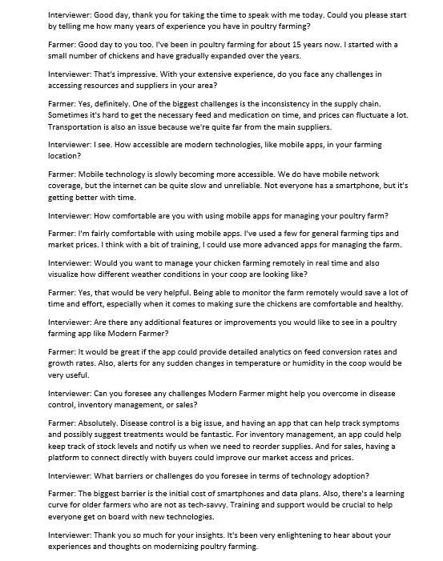

Farmer 2

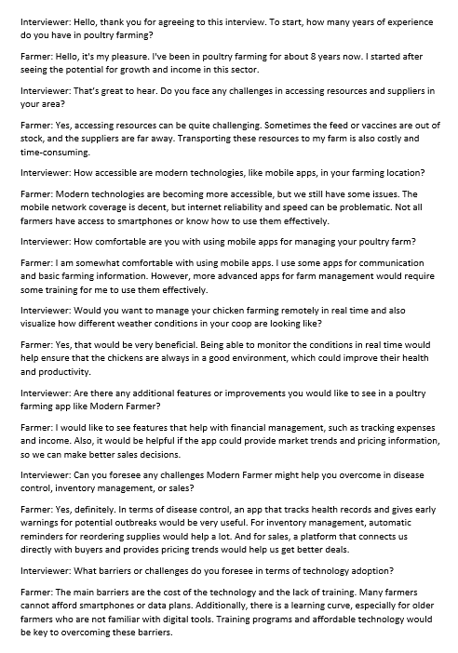

## Questionnaire Response

Farmer 3

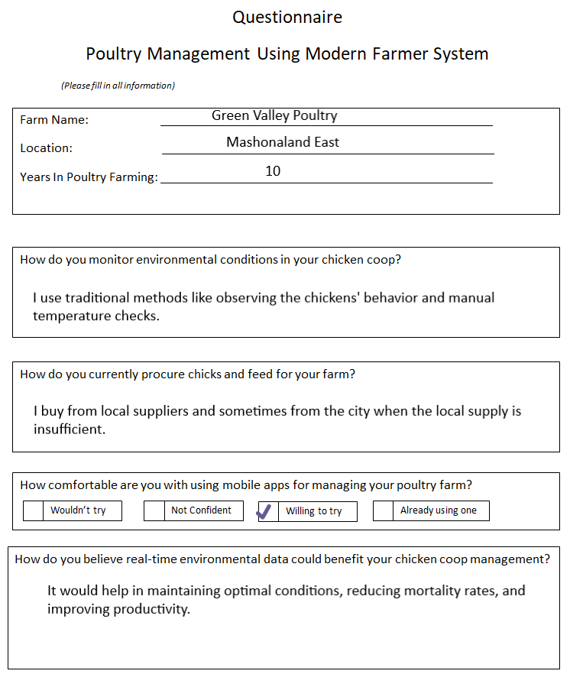

Farmer 4

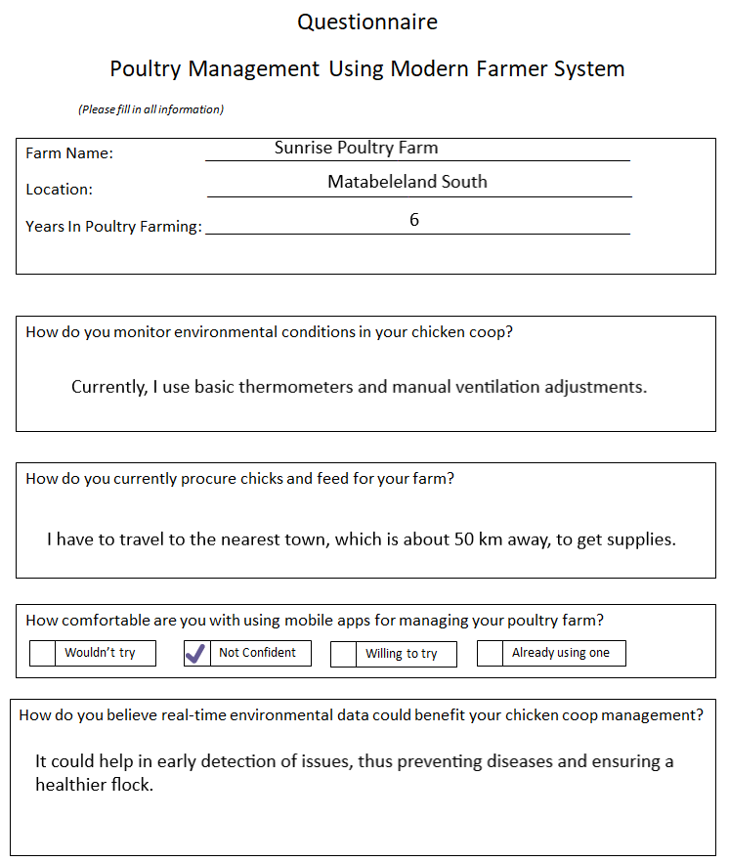

# User Manual

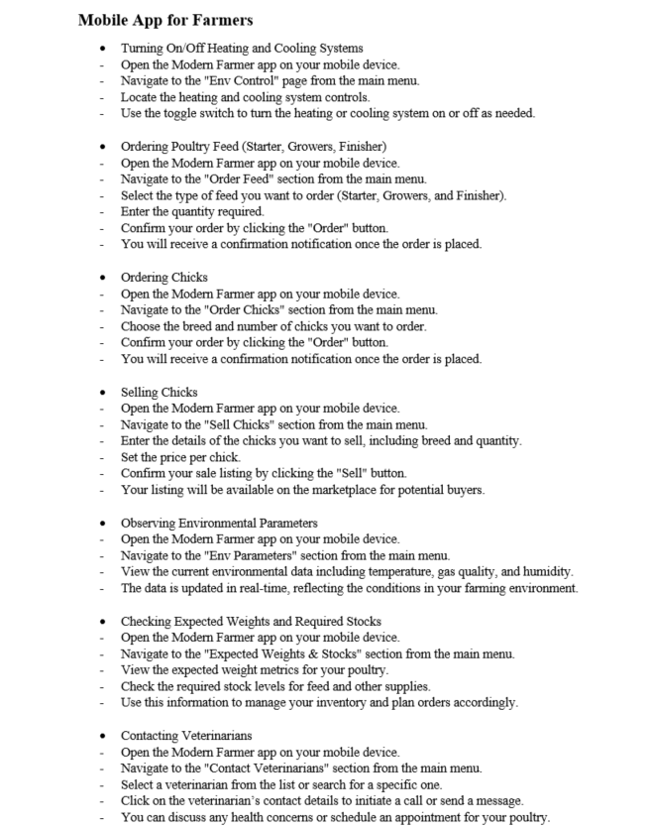

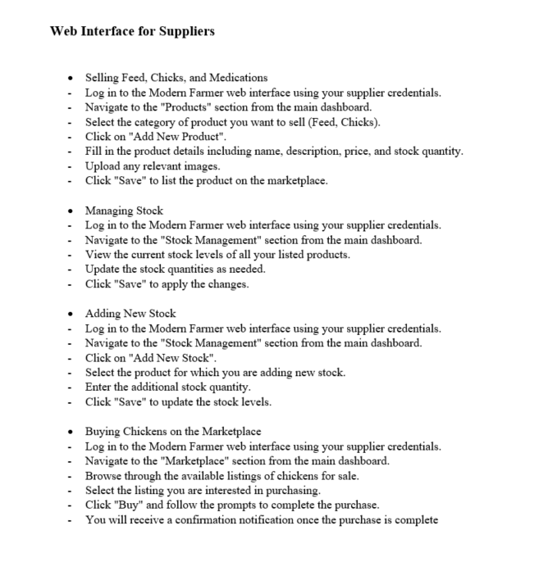

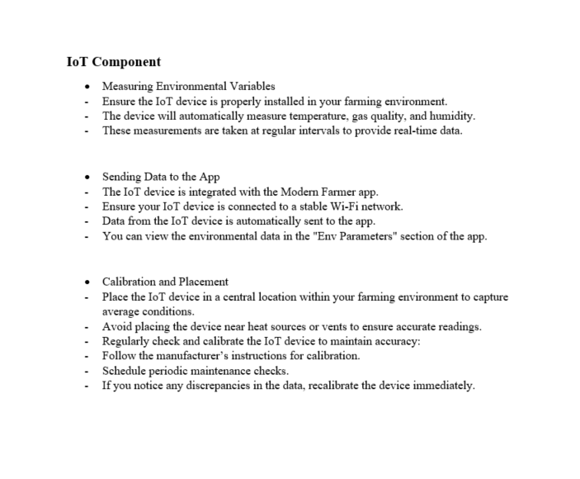

Technical Paper

